CHAPTER 10: Monopoly and Monopsony
Checklist

Can you do the following regarding monopolies and monopsonies?
- Define Monopoly
- Define Monopsony
- Define market power
- Define a multiplant firm
- Define monopoly power
- What factors determine a firm’s elastic demand?
- How is monopoly power tested?
- Define pure monopoly
- What is the social cost of monopoly power
- Define rent-seeking
- Define natural monopoly
- Define an oligopsony
- What are the sources of monopsony power

CHAPTER 10: Monopoly and Monopsony
Monopoly average revenue and marginal revenue
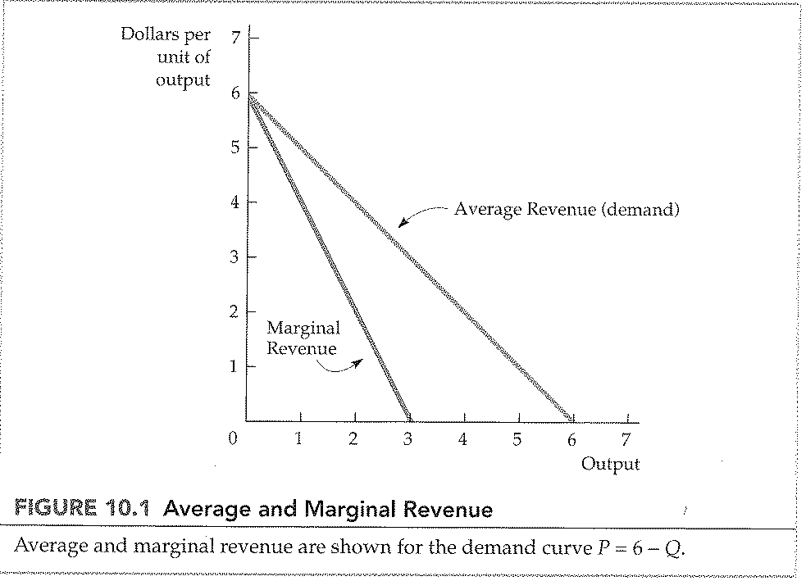
CHAPTER 10: Monopoly and Monopsony
Monopoly average revenue and marginal revenue
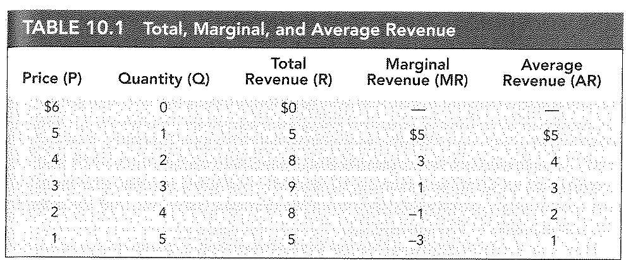

CHAPTER 10: Monopoly and Monopsony
Monopoly: Output decision
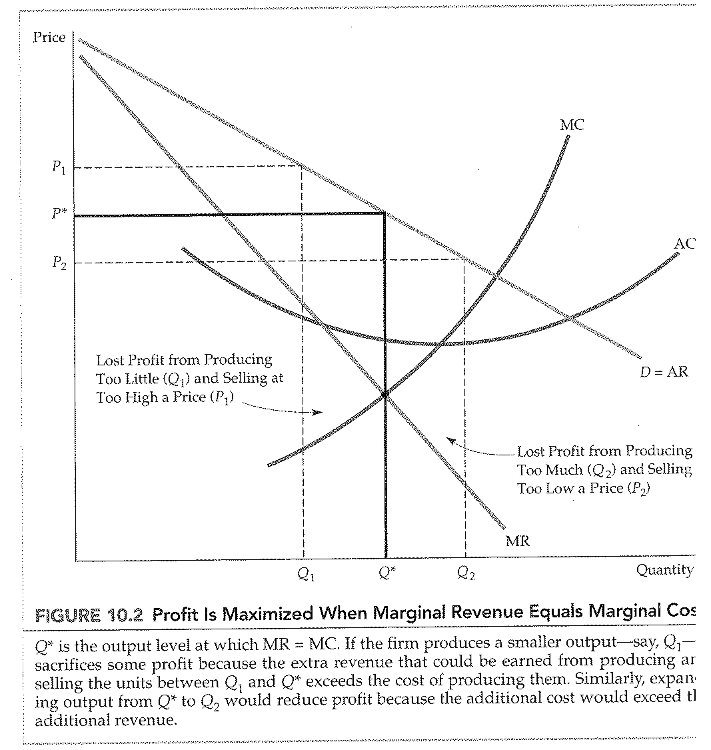

CHAPTER 10: Monopoly and Monopsony
Example of profit maximization
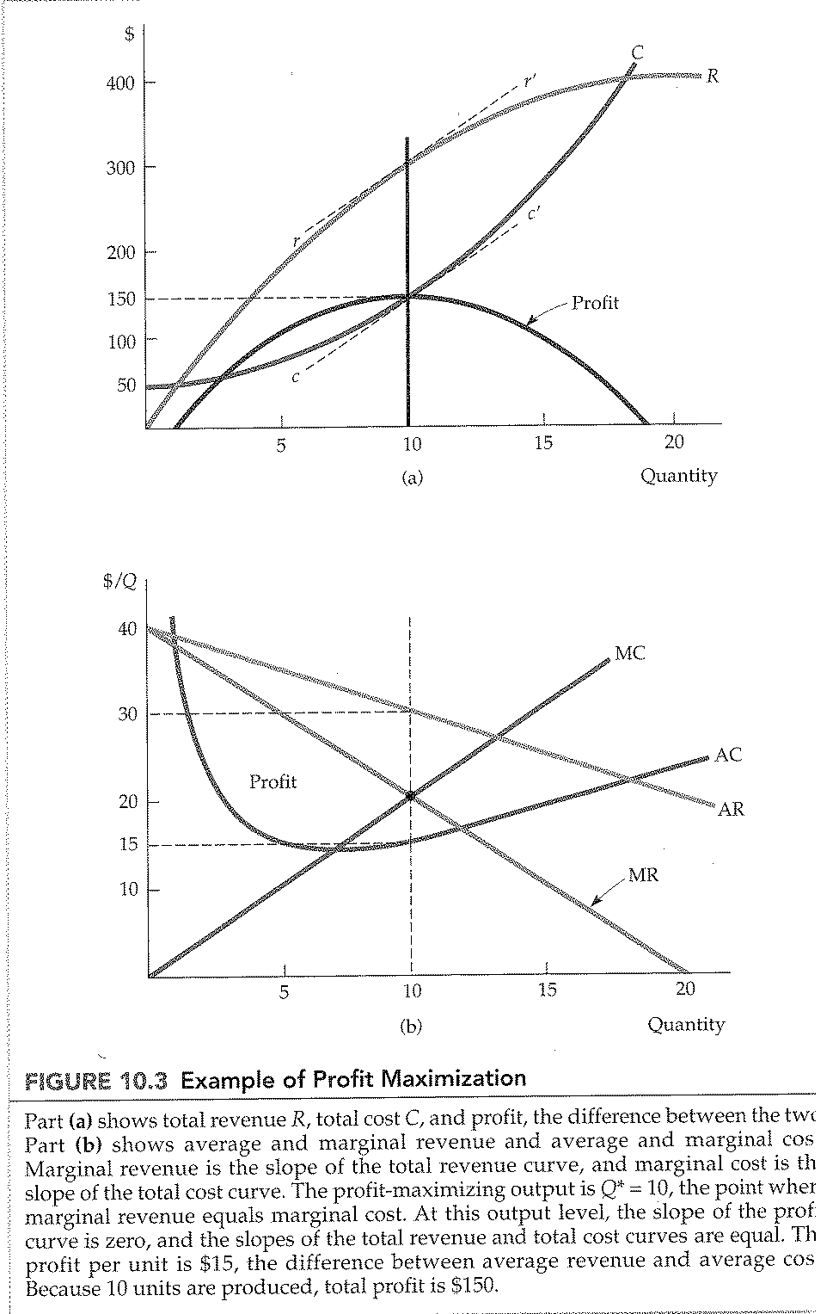

CHAPTER 10: Monopoly and Monopsony
Shifts in demand
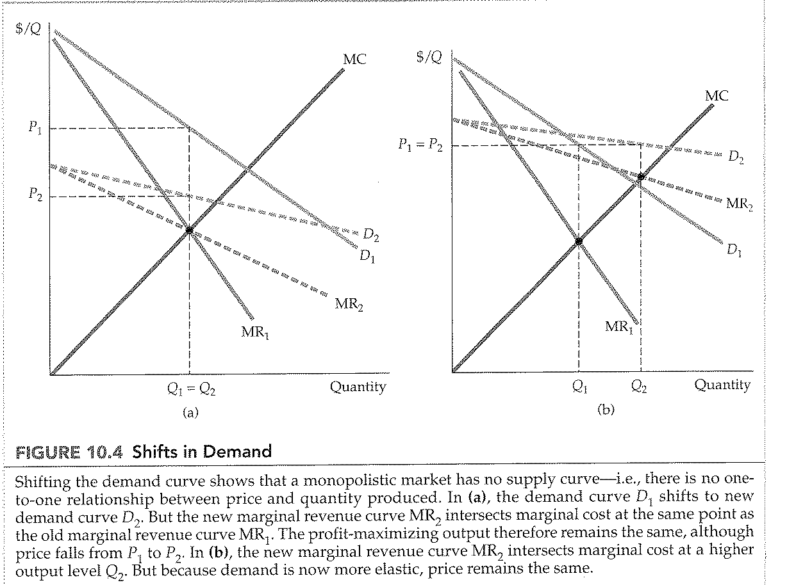
CHAPTER 10: Monopoly and Monopsony
Effect of excise tax on monopolist
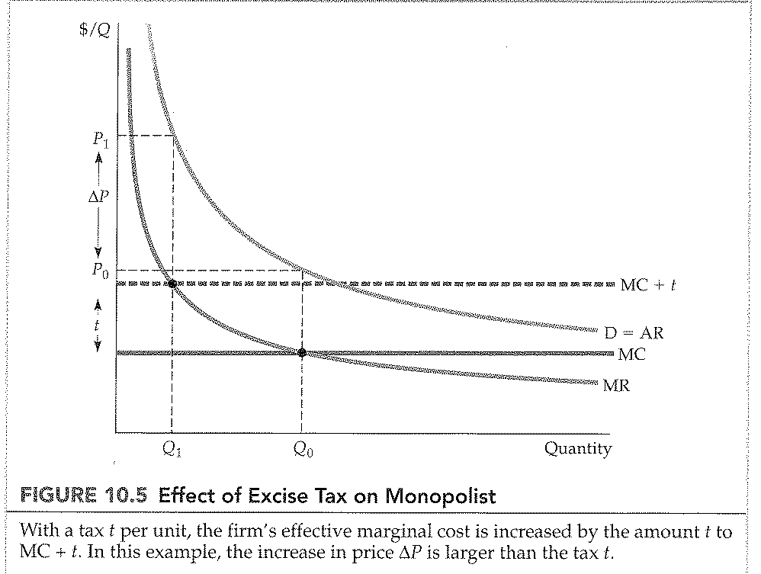
CHAPTER 10: Monopoly and Monopsony
The multiplant firm
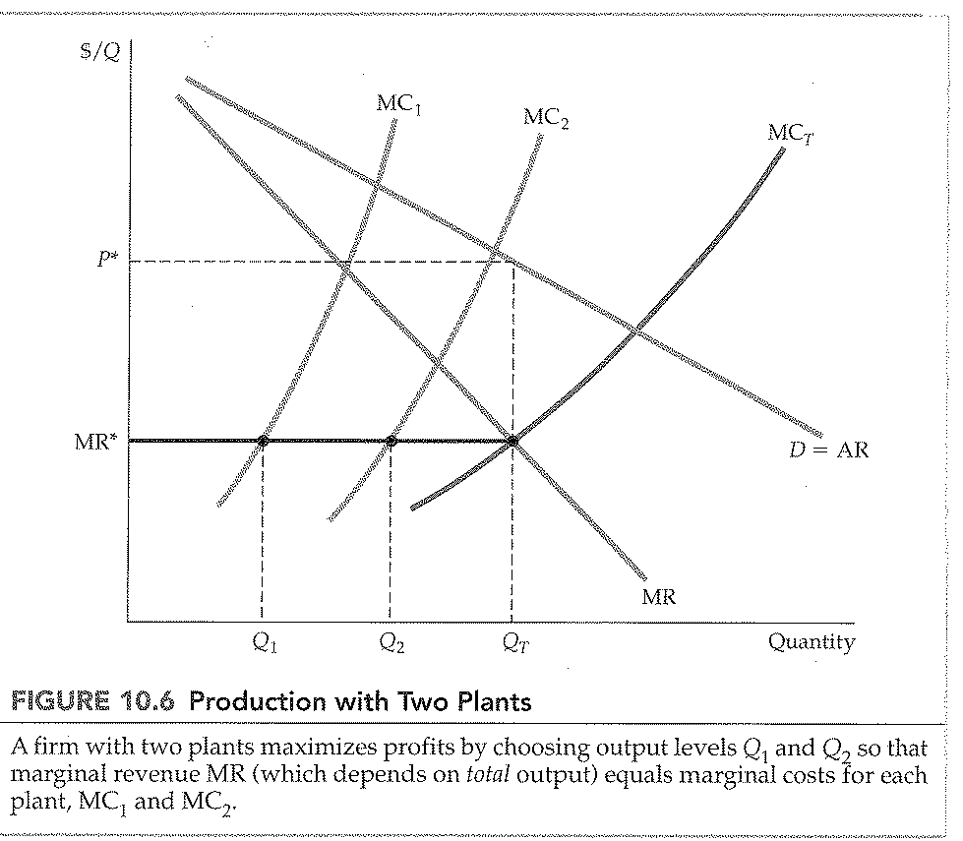

CHAPTER 10: Monopoly and Monopsony
Deadweight loss from monopoly power
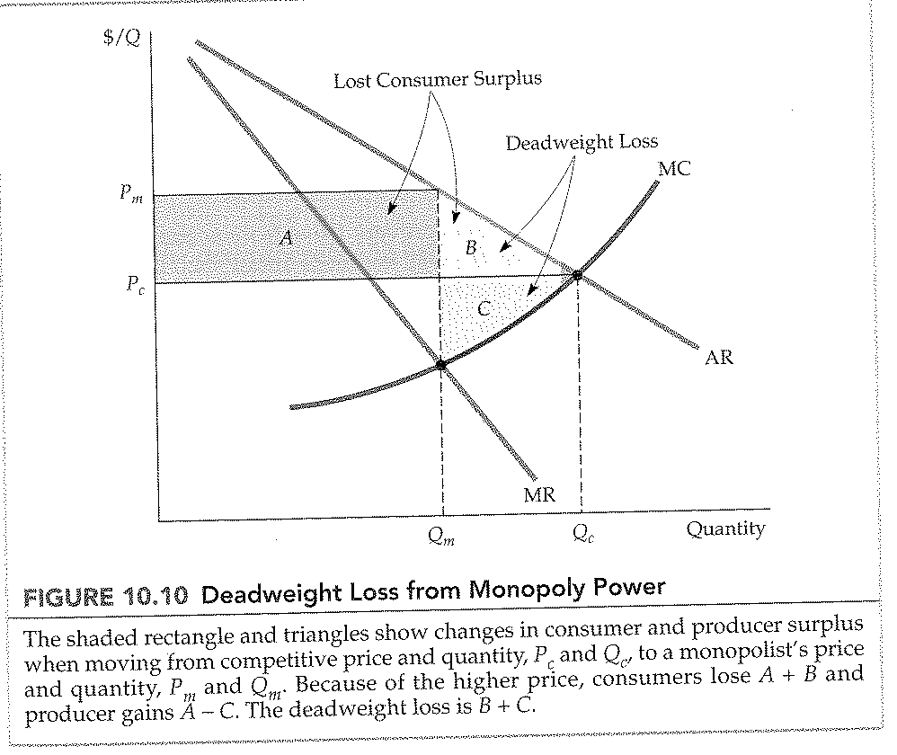

CHAPTER 10: Monopoly and Monopsony
Price regulation
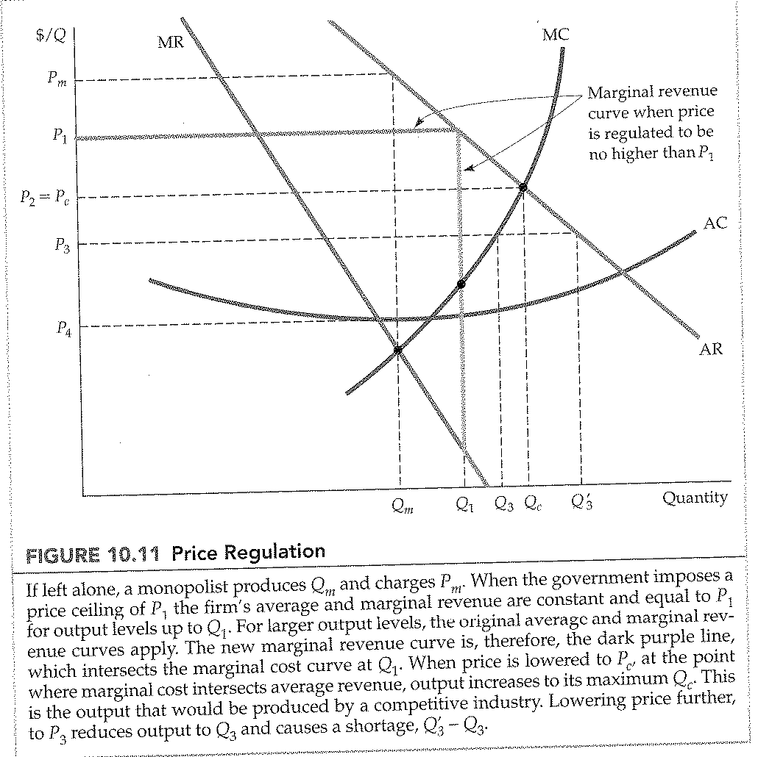

CHAPTER 10: Monopoly and Monopsony
Regulating the price of a natural monopoly
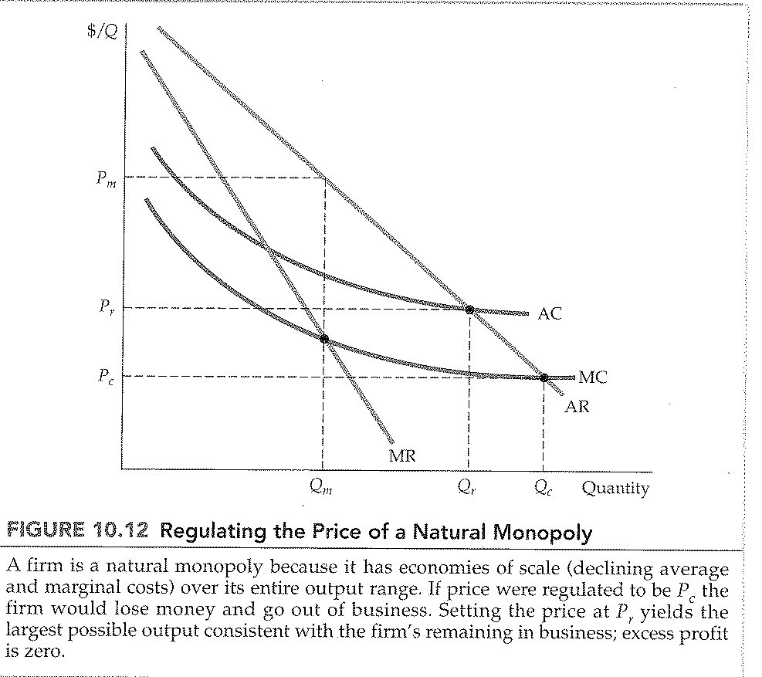

CHAPTER 10: Monopoly and Monopsony
Competitive buyer compared to competitive seller
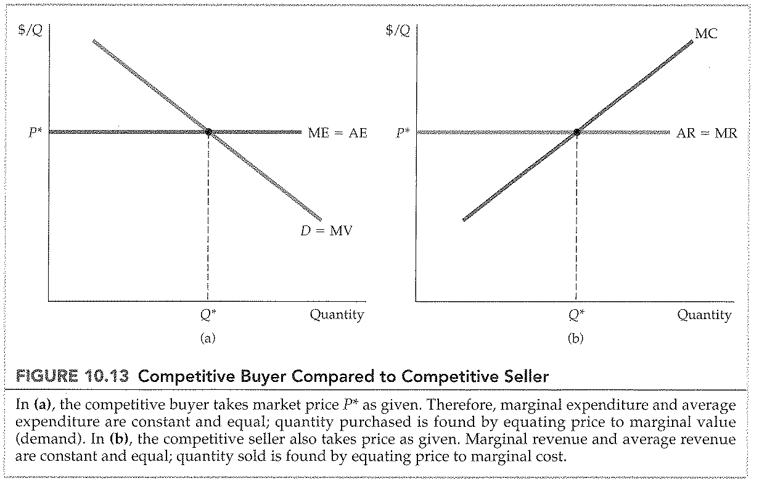
CHAPTER 10: Monopoly and Monopsony
Monopsonist buyer
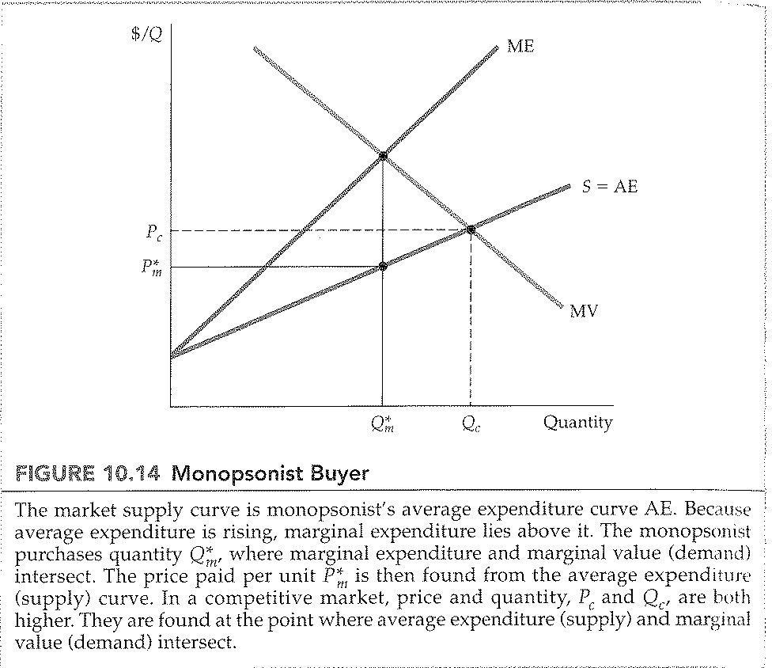
CHAPTER 10: Monopoly and Monopsony
Monopoly and Monopsony
