CHAPTER 11: Pricing with Market Power
Checklist

Can you do the following regarding pricing with market power?
- How is market power capture?
- Define price strategies
- Define price discrimination
- Define first-degree price discrimination
- Define reservation price
- Explain what is perfect price discrimination
- Explain what is imperfect price discrimination
- Define second-degree price discrimination
- Define block pricing
- Define quantity discounts
- Define third-degree price discrimination
- Explain the practice of dividing consumers into groups
- Explain how is it determined who pay what with third-degree price discrimination
- Explain the practice of intertemporal price discrimination
- Explain the practice of peak-loaded pricing
- Define a two part tariff
- Define bundling
- Explain the process of bundling by use of an example
- Explain the concept of relative valuations
- Define mixed bundling
- Define pure bundling
- Explain bundling in practice
- Define tying
- How do firms use advertising?

CHAPTER 11: Pricing with Market Power
Capturing consumer surplus
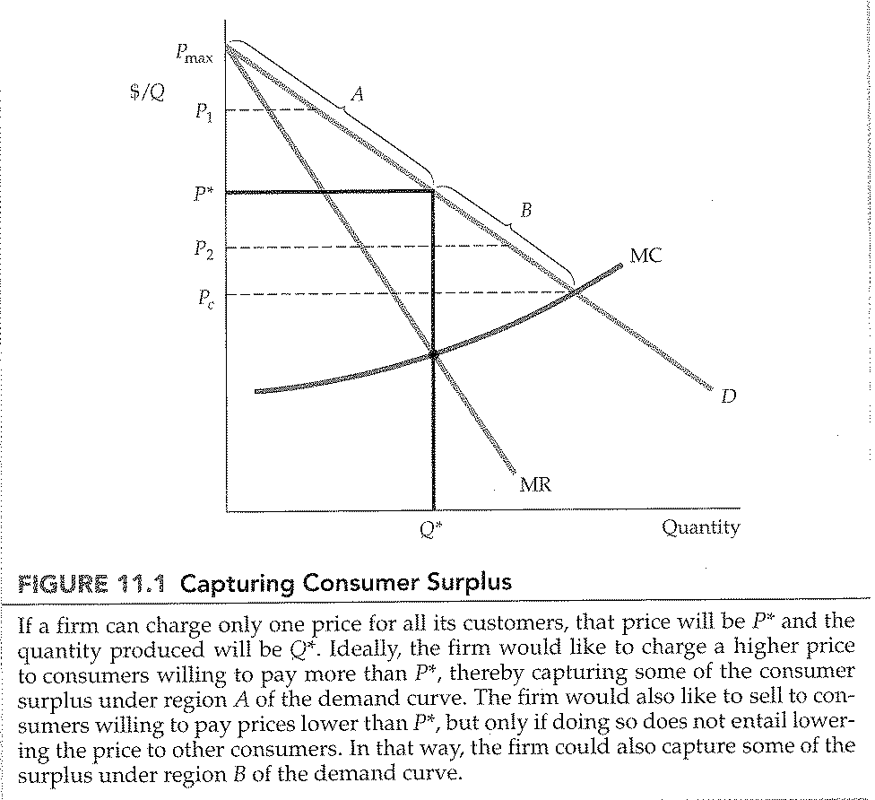
CHAPTER 11: Pricing with Market Power
Additional profit from perfect first-degree price discrimination
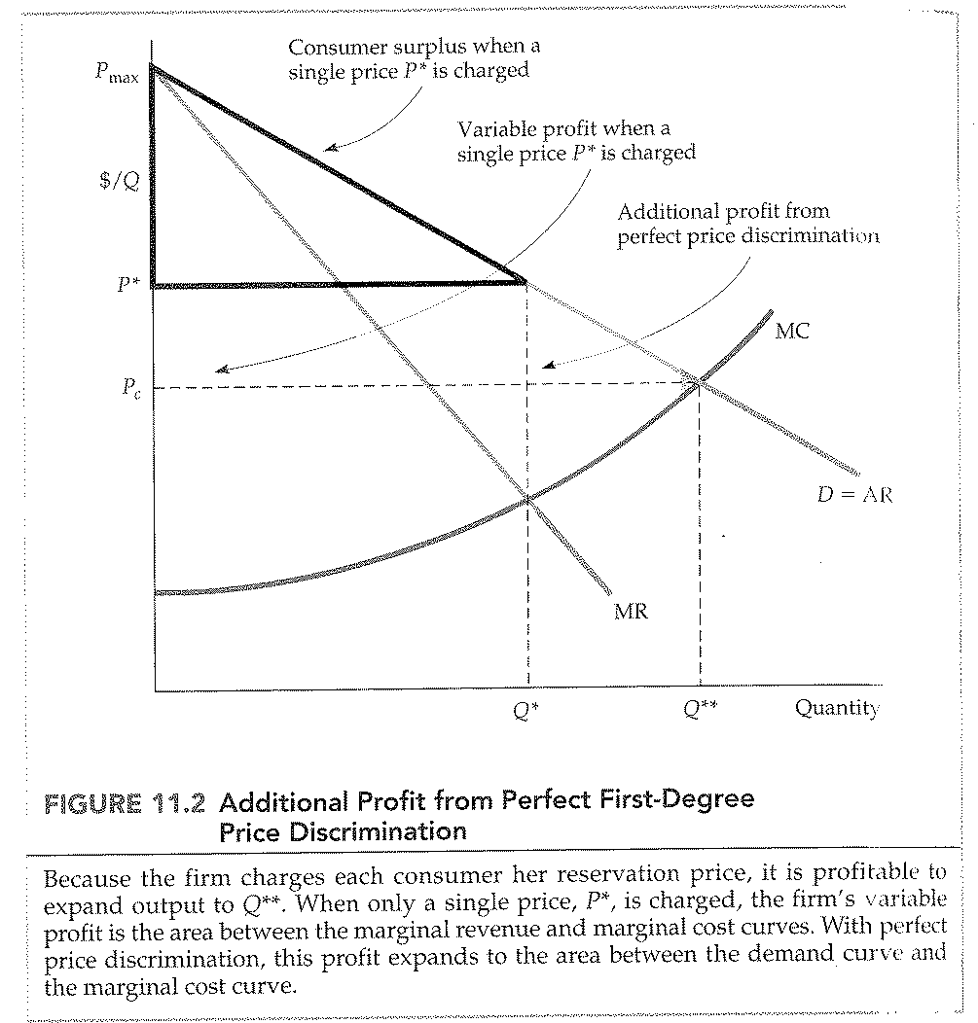
CHAPTER 11: Pricing with Market Power
First-degree price discrimination in practice
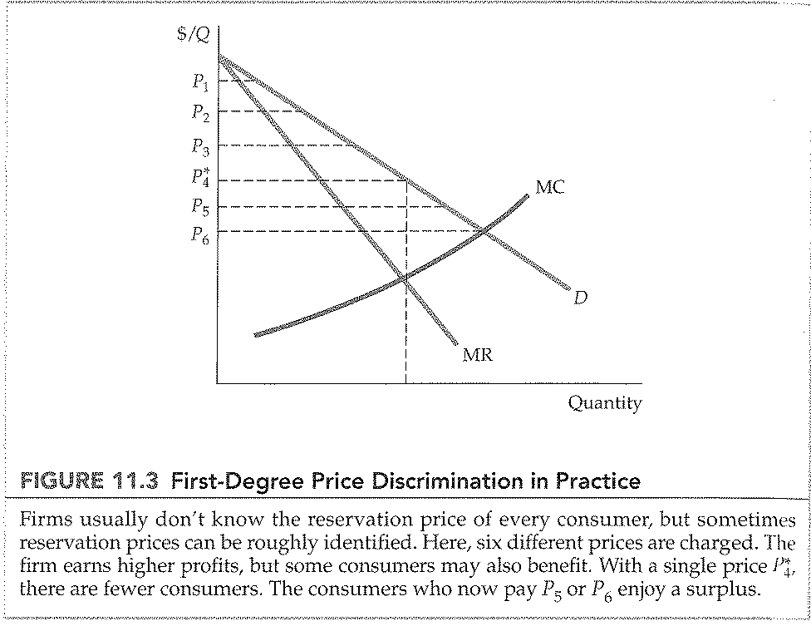

CHAPTER 11: Pricing with Market Power
Second-degree price discrimination
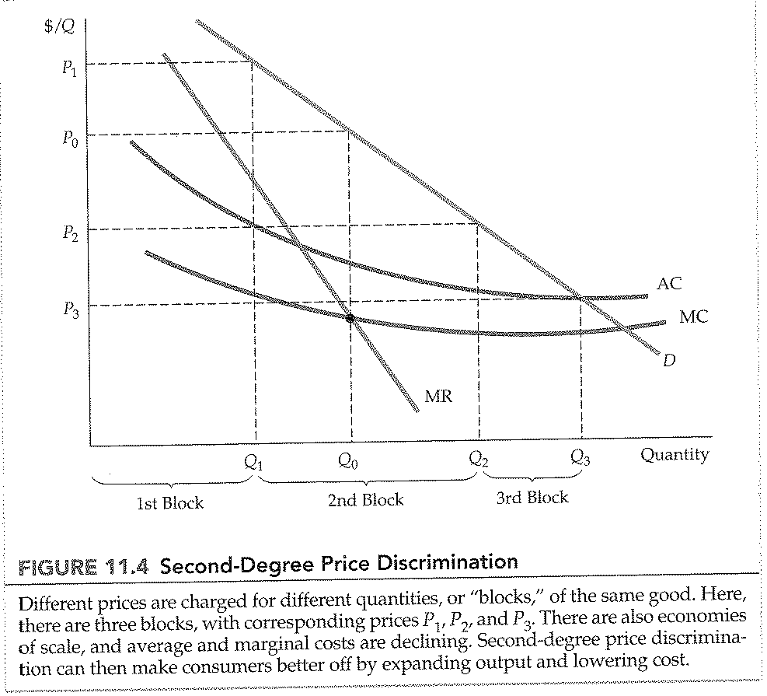

CHAPTER 11: Pricing with Market Power
Third-degree price discrimination
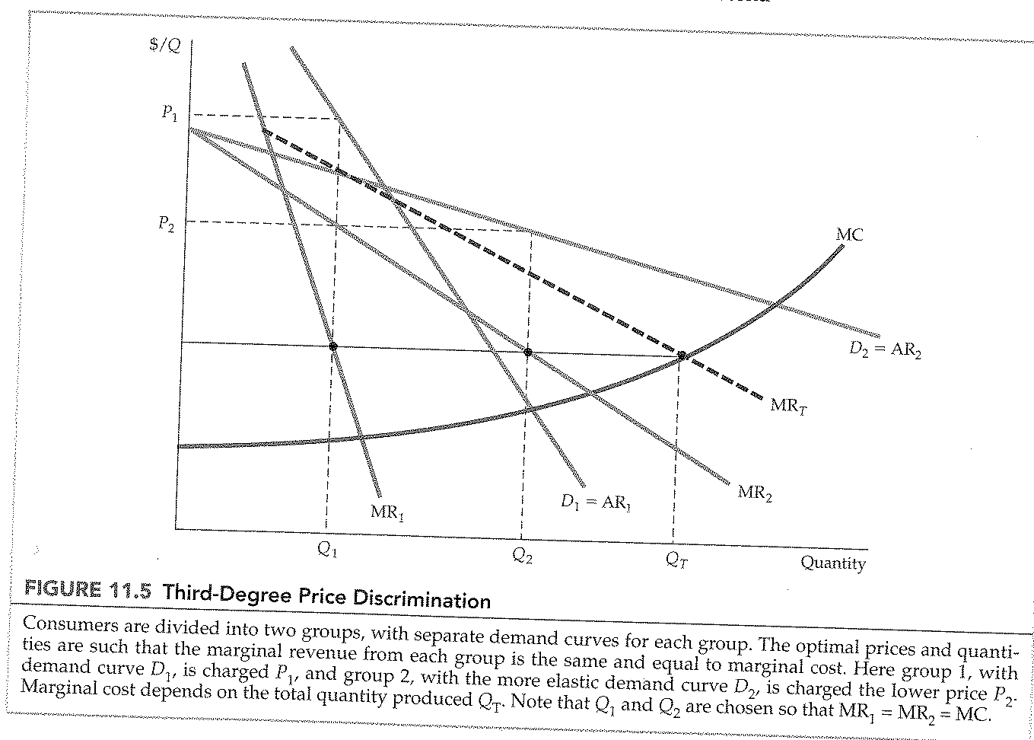
CHAPTER 11: Pricing with Market Power
No sales to smaller markets
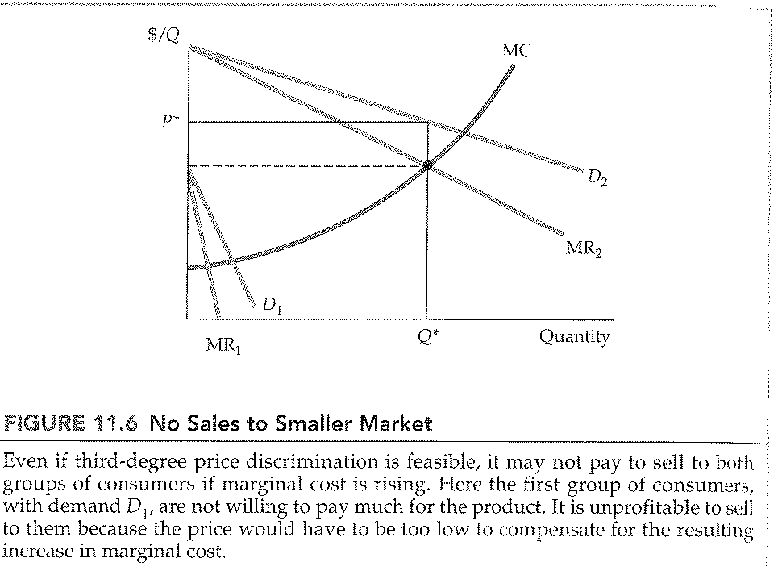
CHAPTER 11: Pricing with Market Power
Intertemporal price discrimination
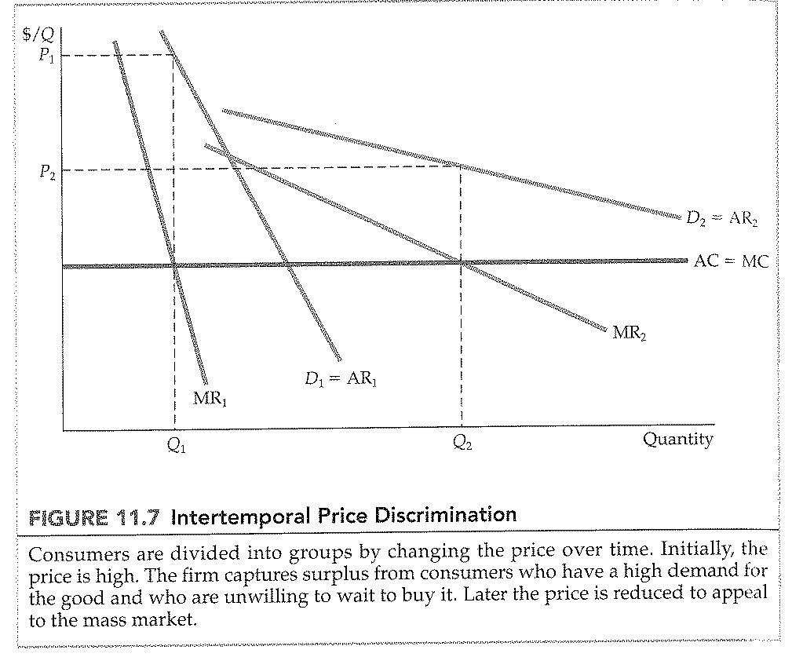
CHAPTER 11: Pricing with Market Power
Peak-load pricing
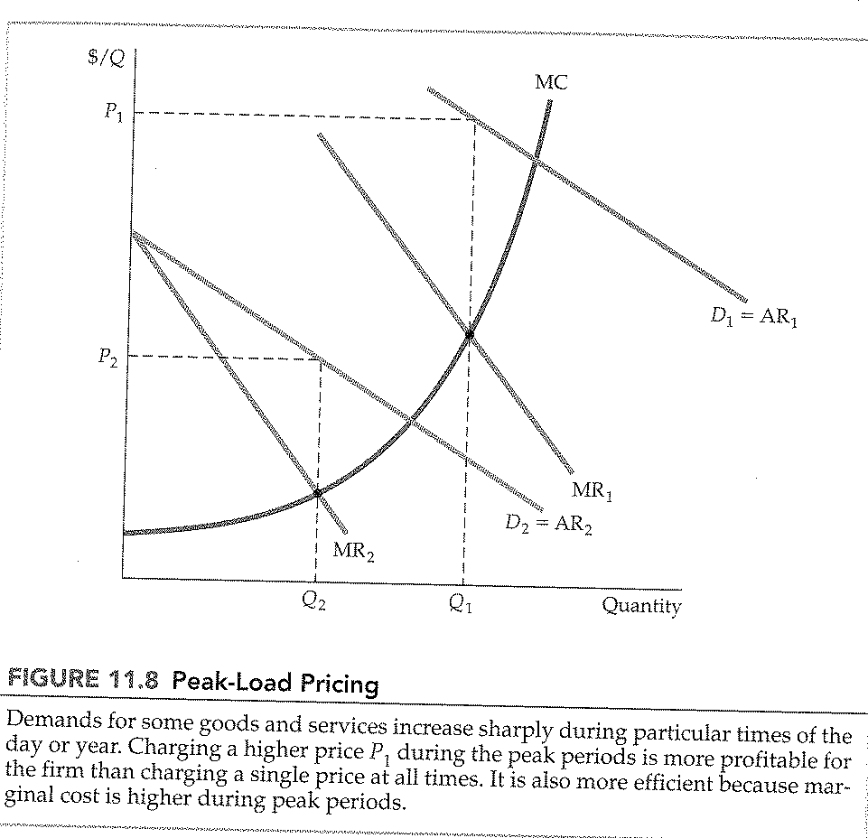

CHAPTER 11: Pricing with Market Power
Reservation price
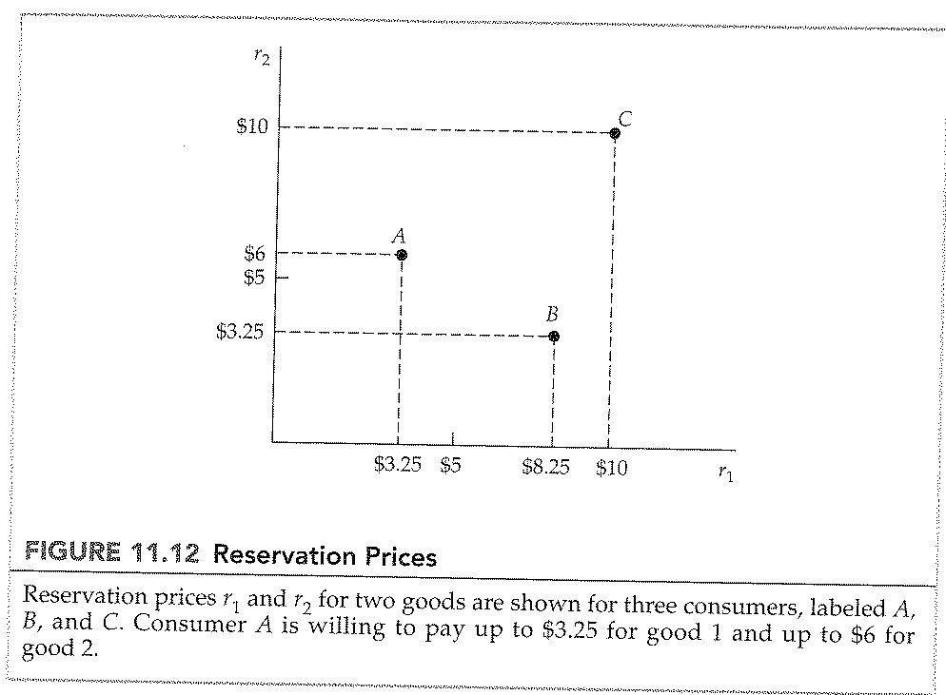

CHAPTER 11: Pricing with Market Power
Consumption decisions when products are sold separately
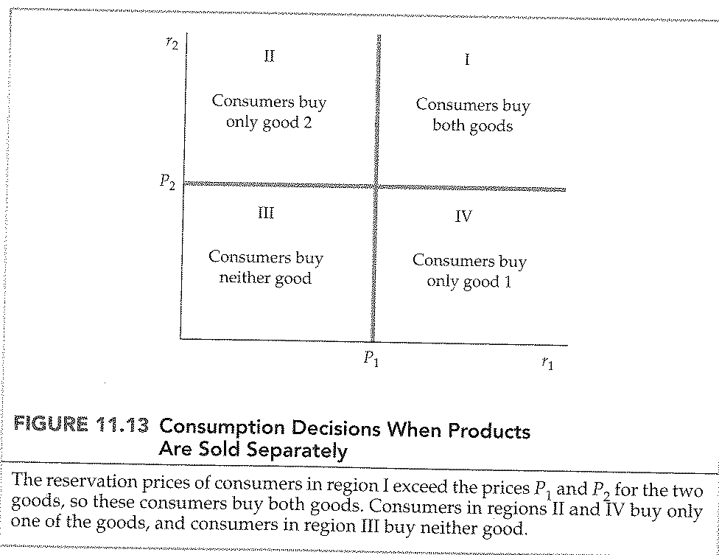

CHAPTER 11: Pricing with Market Power
Consumption decisions when products are bundled
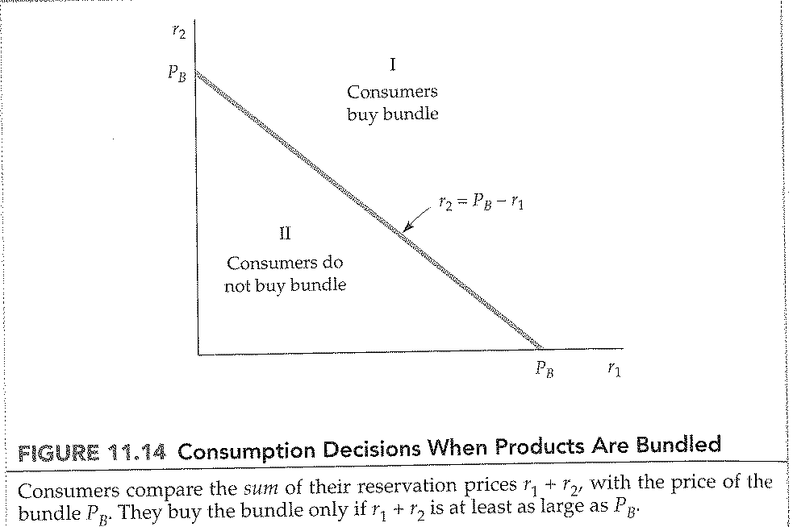
CHAPTER 11: Pricing with Market Power
Reservation price: positive and negative correlation
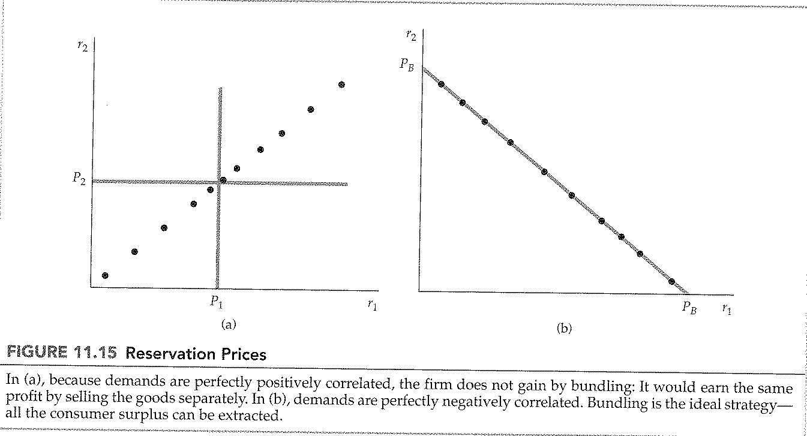

CHAPTER 11: Pricing with Market Power
Mixed versus pure bundling
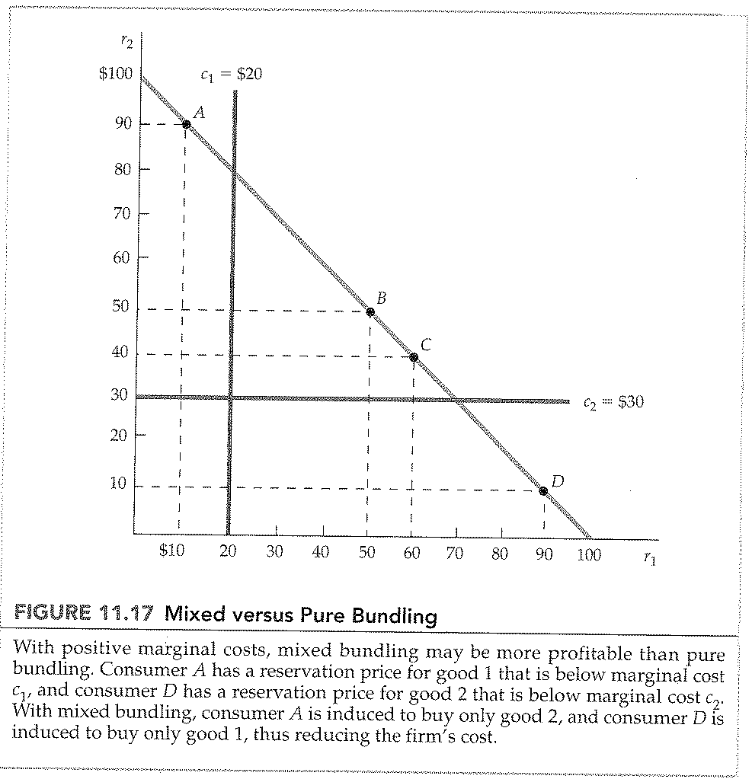

CHAPTER 11: Pricing with Market Power
Mixed bundling with zero marginal costs
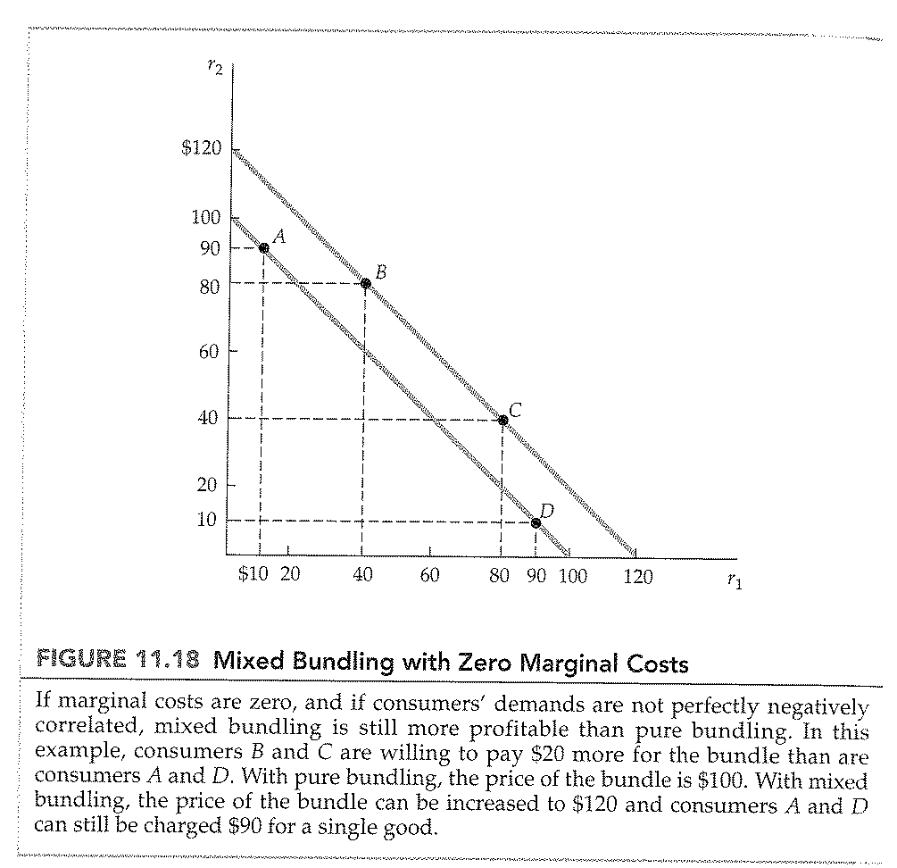

CHAPTER 11: Pricing with Market Power
Mixed bundling in practice
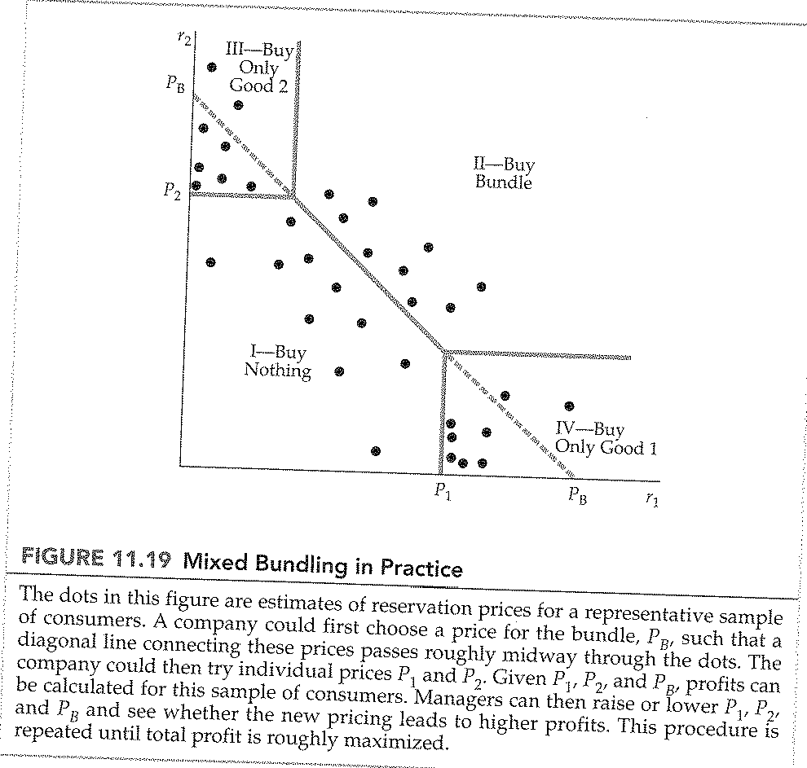

CHAPTER 11: Pricing with Market Power
Effects of advertising
