CHAPTER 12: Monopolistic competition and Oligopoly
Checklist

Can you do the following regarding pricing with market power?
- Define Monopolistic Competition
- Explain the characteristics of Monopolistic Competition
- What are the 2 key characteristics?
- Why is perfect competition desirable?
- What are the 2 sources of inefficiency in monopolistic competition?
- Should monopolistic competition markets be regulated? Why?
- Define Oligopoly
- Discuss the characteristics of Oligopoly
- Define duopoly
- Explain what is the Nash equilibrium
- Discuss the Cournot model
- Define reaction curve
- Discuss the Stackleberg model
- Discuss the Bertrand model
- Discuss the ‘prisoner’s dilemma’
- Define payoff matrix
- Define price rigidity
- Explain the kinked demand curve
- Define price signaling
- Define price leadership
- Define dominant firm
- Explain what is a cartel

CHAPTER 12: Monopolistic competition and Oligopoly
Monopolistic competitive firm in SR and LR
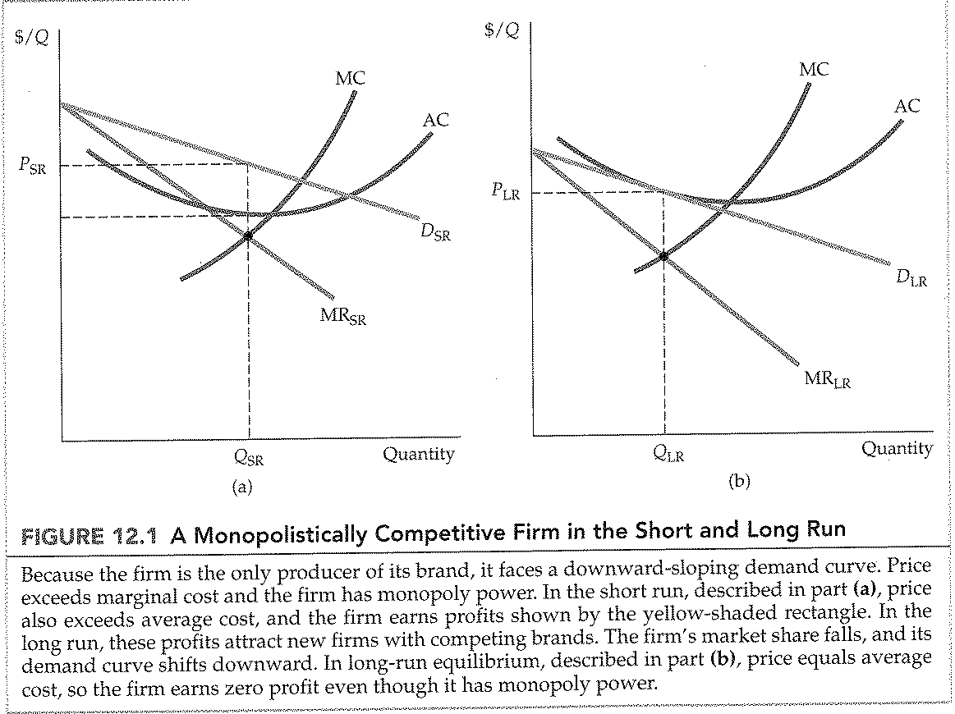
CHAPTER 12: Monopolistic competition and Oligopoly
Monopolistic competition equilibrium vs. perfectly competitive equilibrium
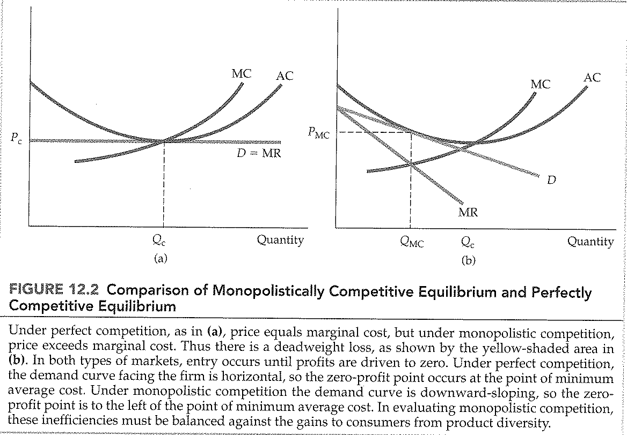
CHAPTER 12: Monopolistic competition and Oligopoly
Firm 1’s output decision
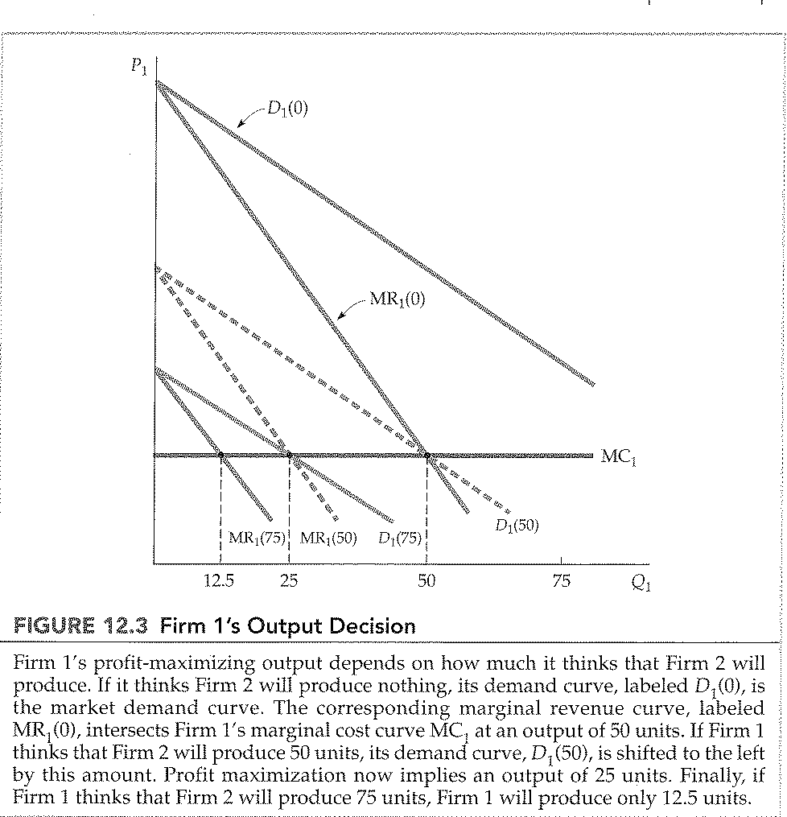

CHAPTER 12: Monopolistic competition and Oligopoly
Reaction curve and Cournot model equilibrium
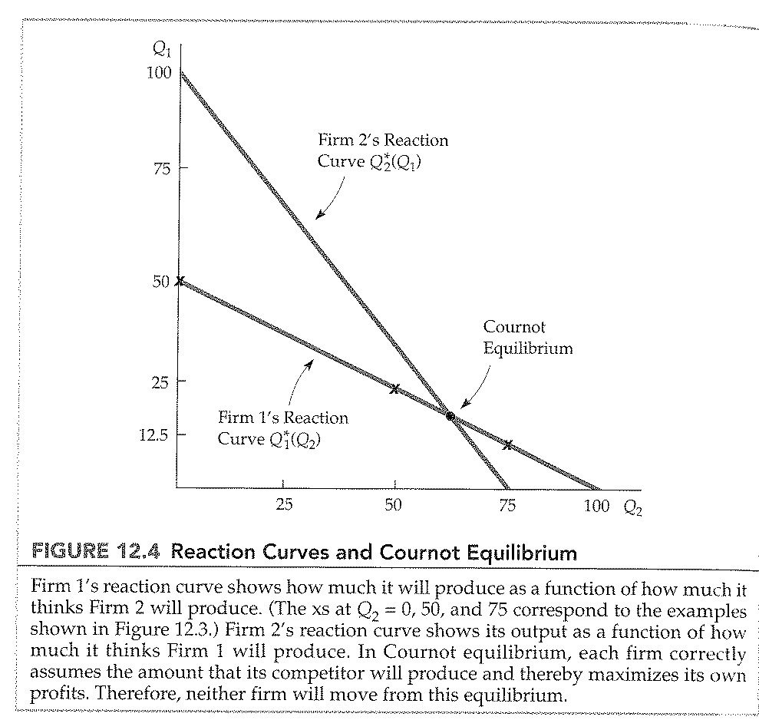

CHAPTER 12: Monopolistic competition and Oligopoly
Nash equilibrium in prices
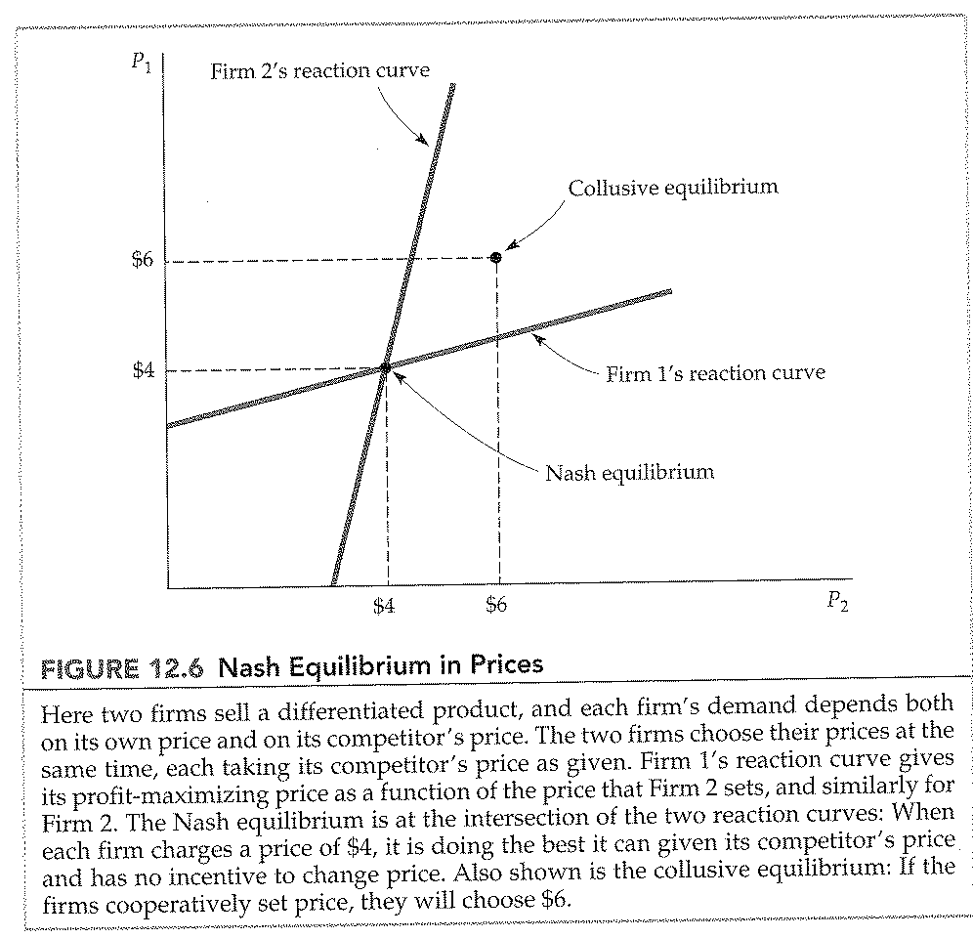
CHAPTER 12: Monopolistic competition and Oligopoly
The kinked demand curve
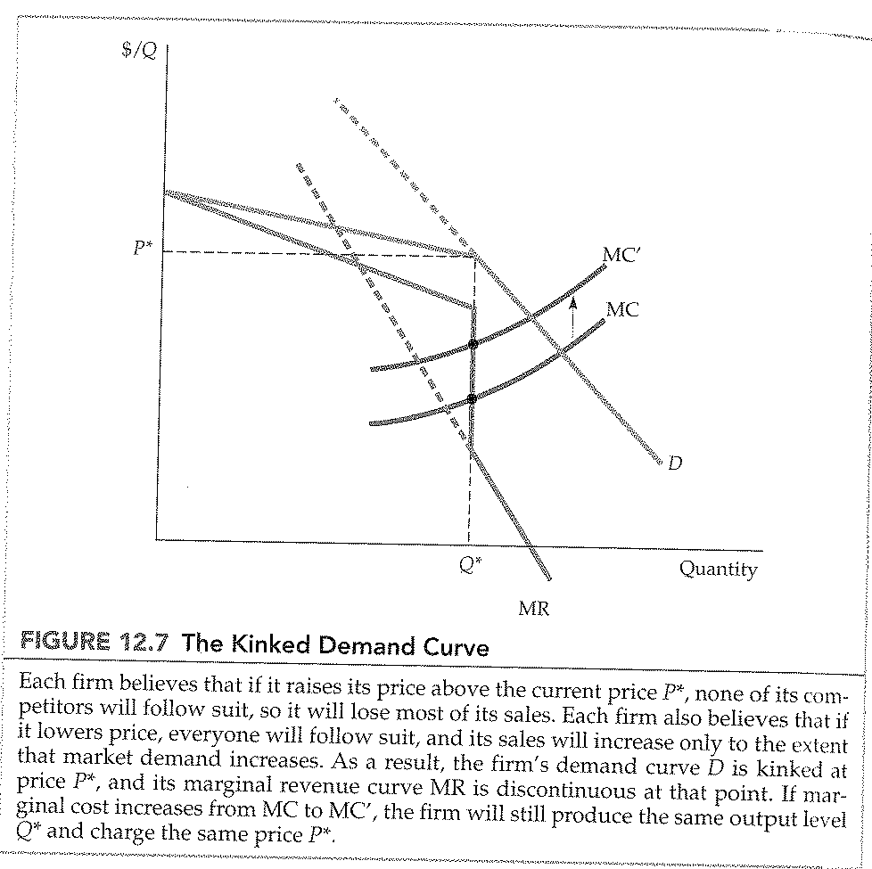
CHAPTER 12: Monopolistic competition and Oligopoly
Price setting by a Dominant firm
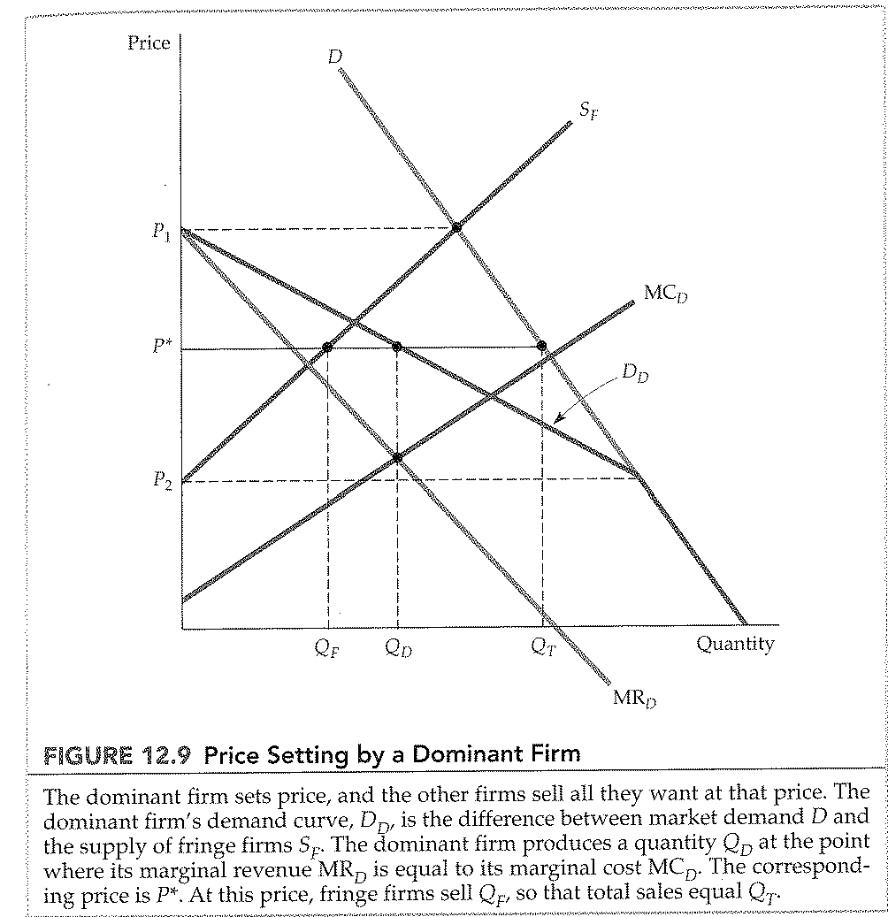
CHAPTER 12: Monopolistic competition and Oligopoly
The OPEC oil cartel
