CHAPTER 14: Market for factor inputs
Checklist

Can you do the following regarding a market for factor inputs?
- Define a competitive factor market
- Define derived demand
- How do you determine derived demand?
- Define marginal revenue product of labour
- Define average expenditure firm
- Define marginal expenditure firm
- Explain the backward-bending supply of labour

CHAPTER 14: Market for factor inputs
Marginal revenue product
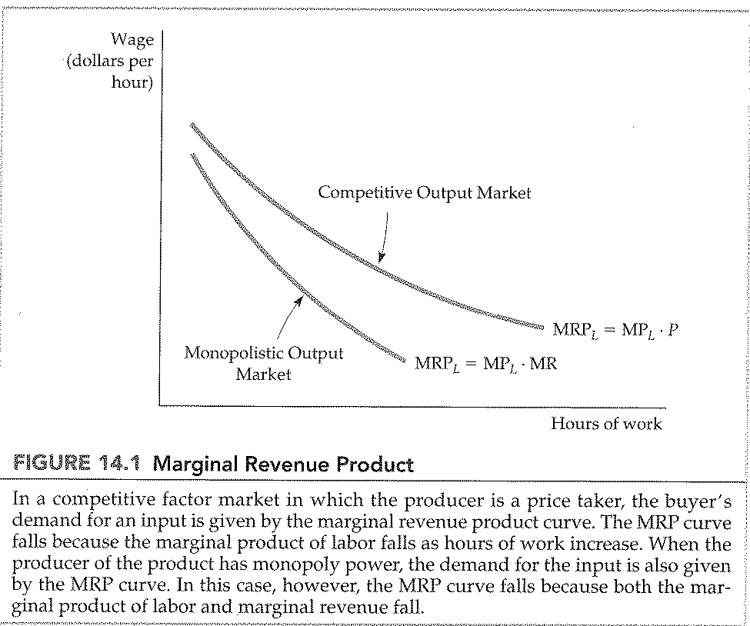
CHAPTER 14: Market for factor inputs
Hiring by a firm in the labour market
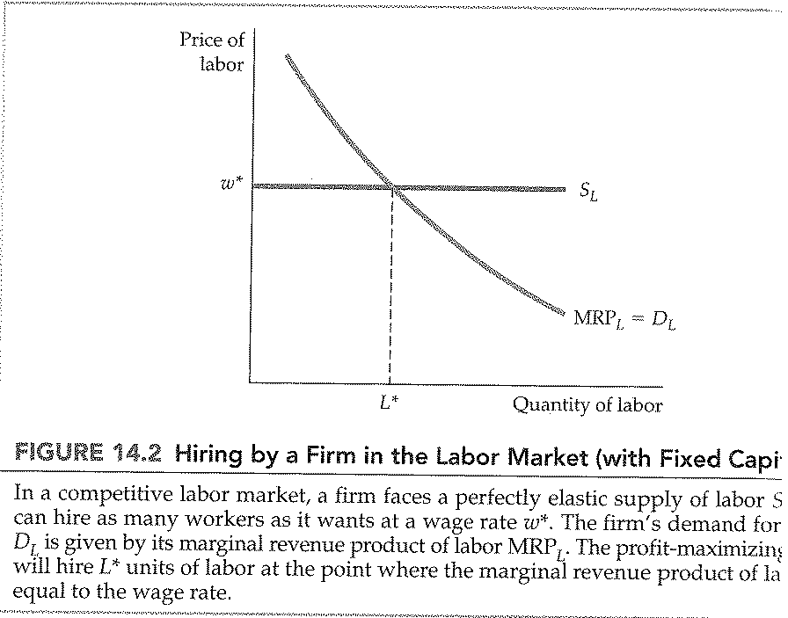
CHAPTER 14: Market for factor inputs
A shift in the supply of labour with fixed capital
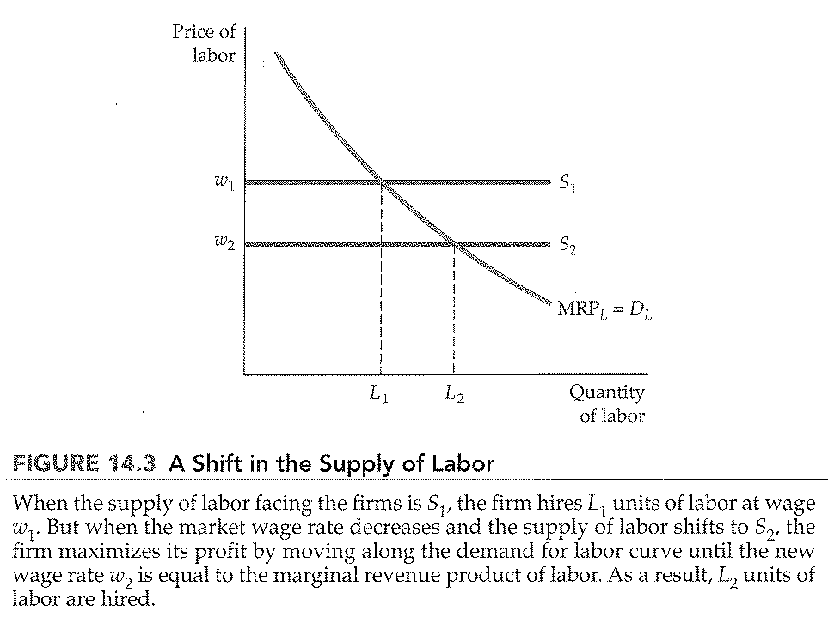

CHAPTER 14: Market for factor inputs
Firm’s demand curve for labour with variable capital
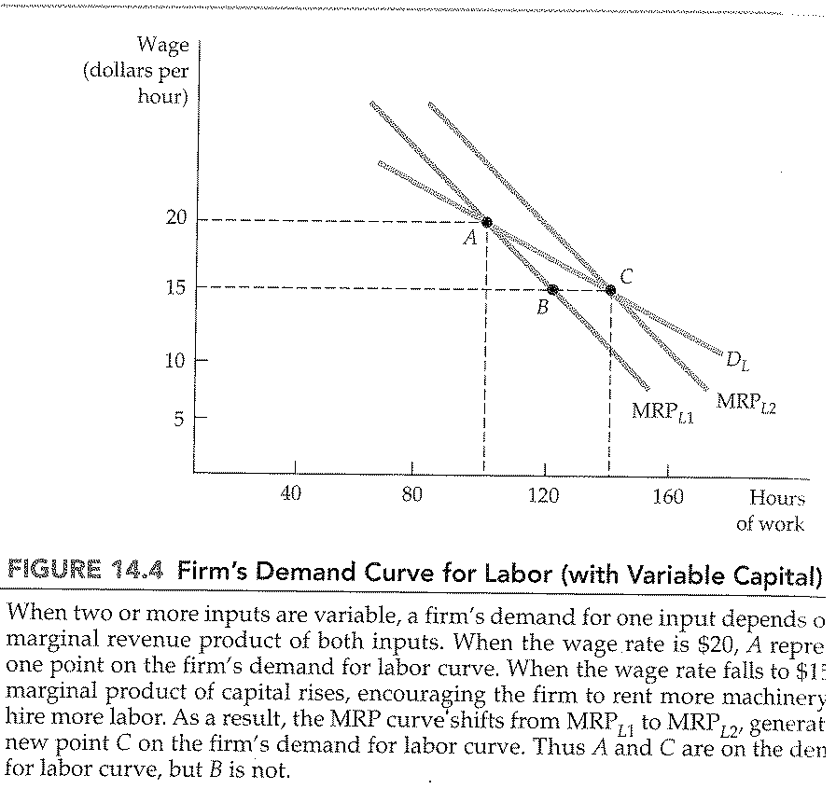
CHAPTER 14: Market for factor inputs
The industry demand for labour
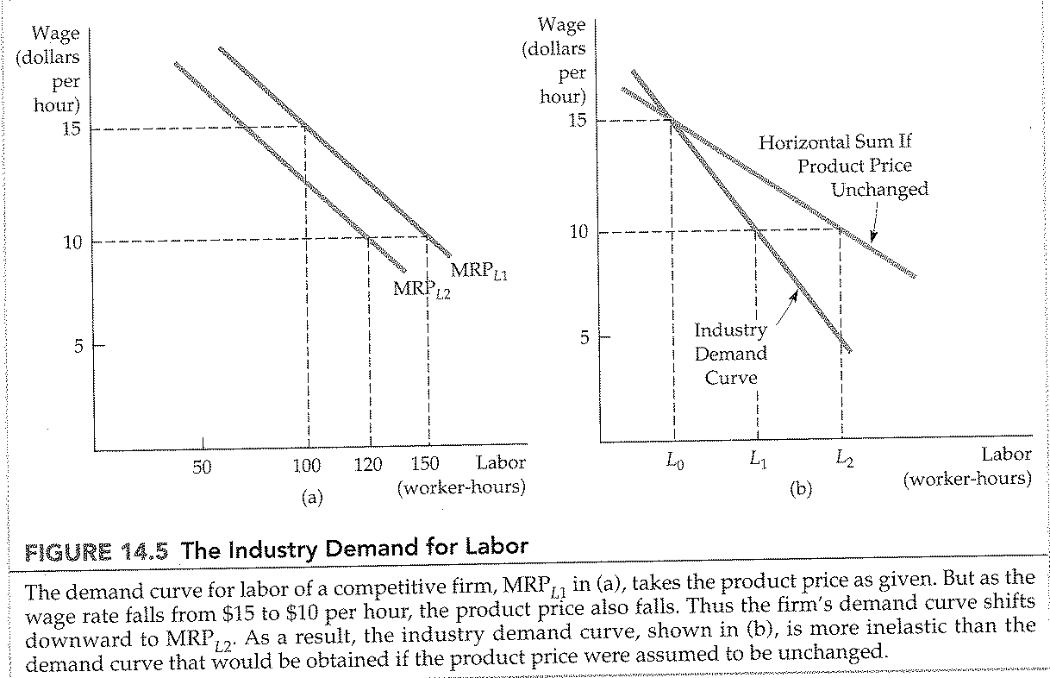

CHAPTER 14: Market for factor inputs
A firm’s input supply in a competitive factor market
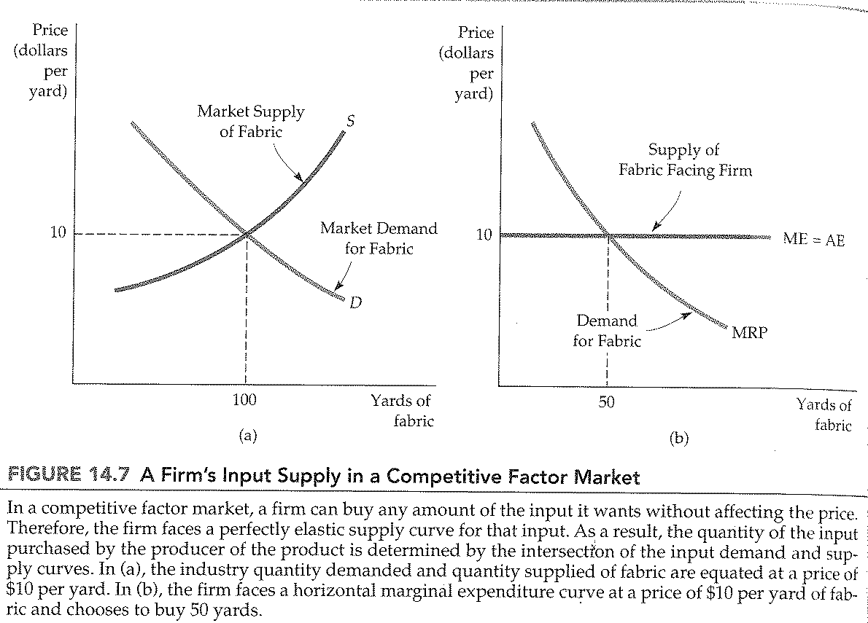
CHAPTER 14: Market for factor inputs
Backward-bending supply of labour
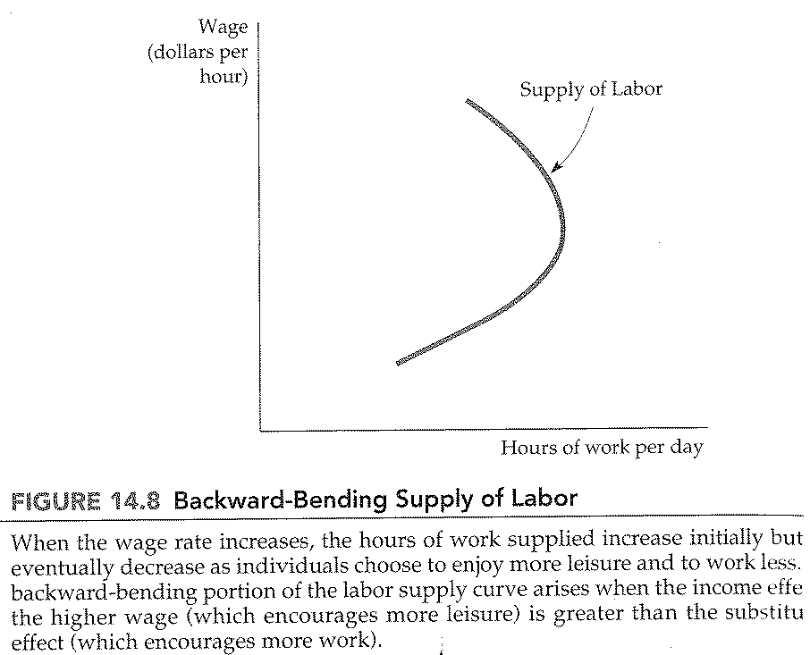

CHAPTER 14: Market for factor inputs
Substitution and income effect of a wage increase
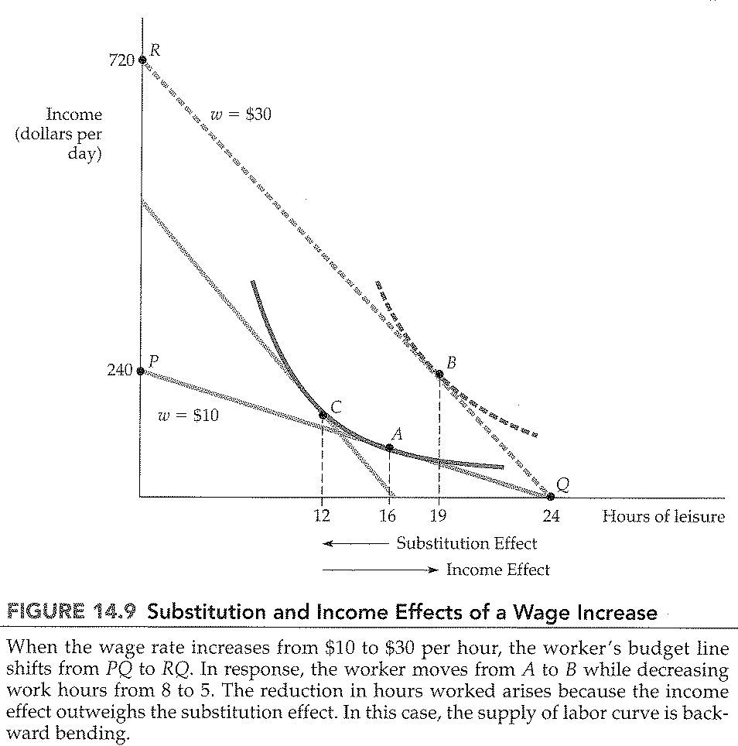
CHAPTER 14: Market for factor inputs
Labour market equilibrium
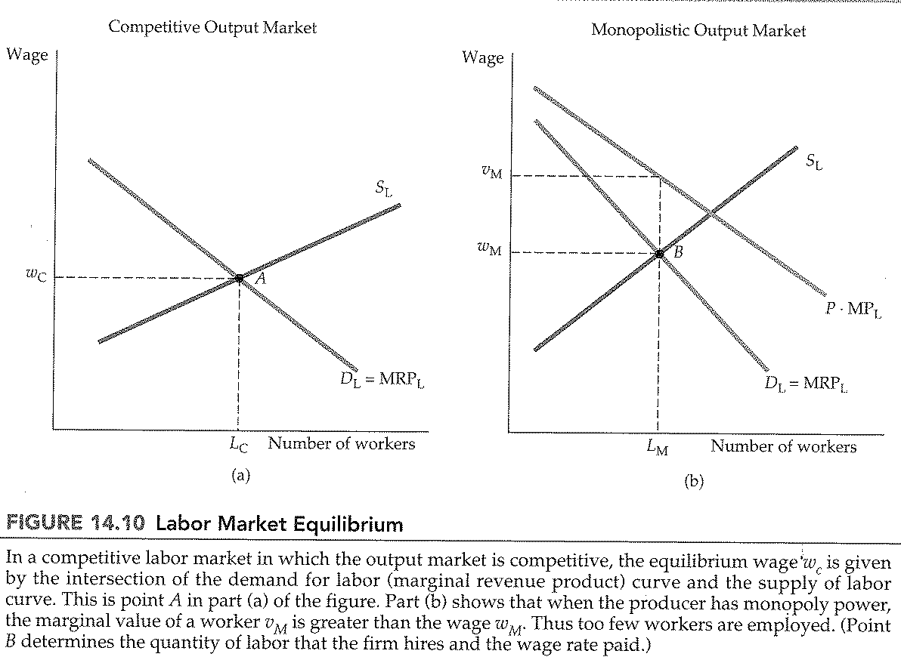

CHAPTER 14: Market for factor inputs
Economic rent
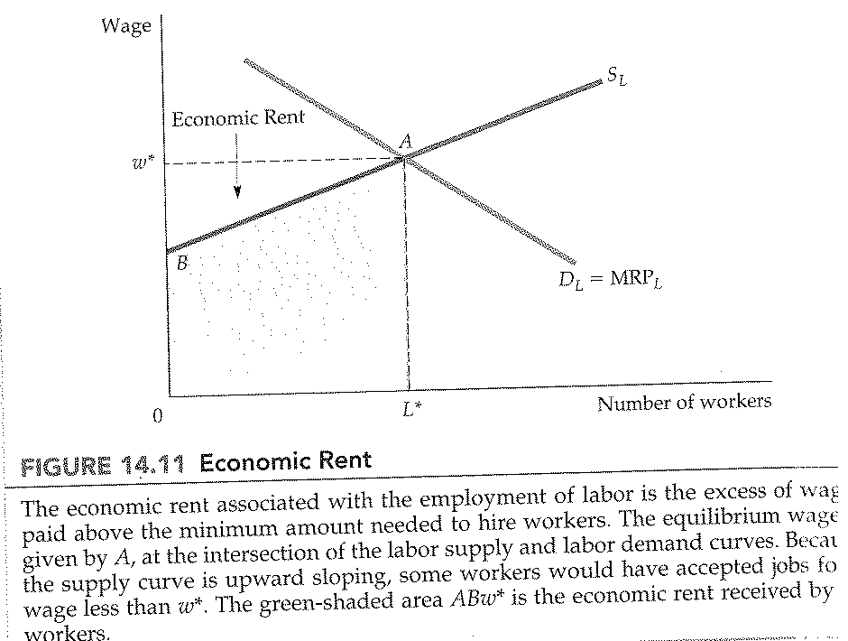

CHAPTER 14: Market for factor inputs
Land rent
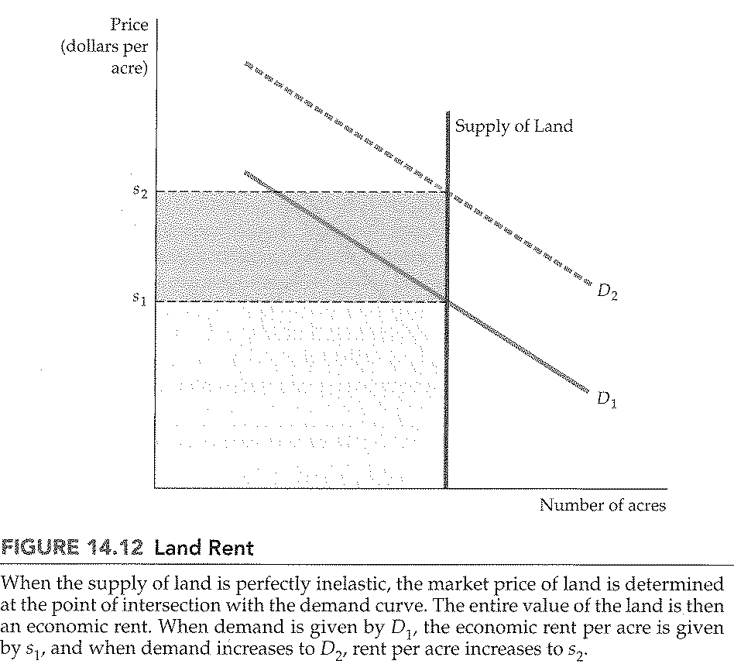
CHAPTER 14: Market for factor inputs
Marginal and average expenditure
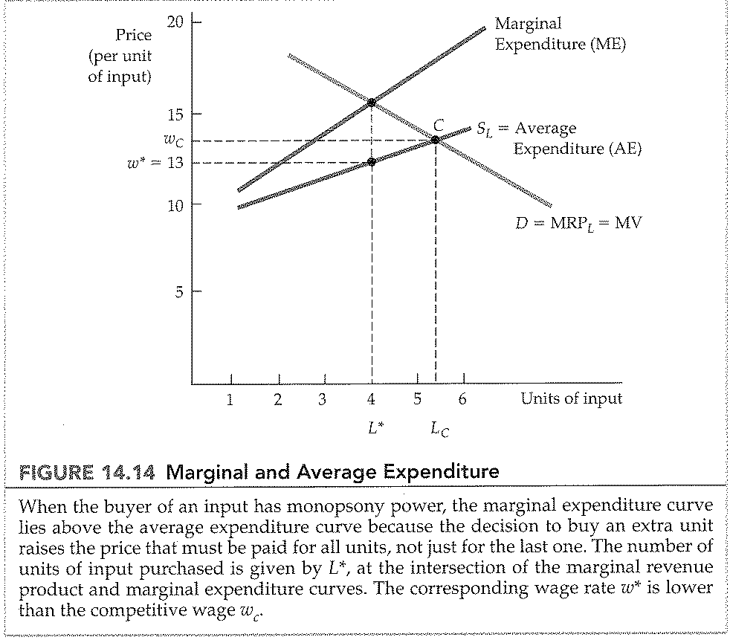
CHAPTER 14: Market for factor inputs
Monopoly power of sellers of labour
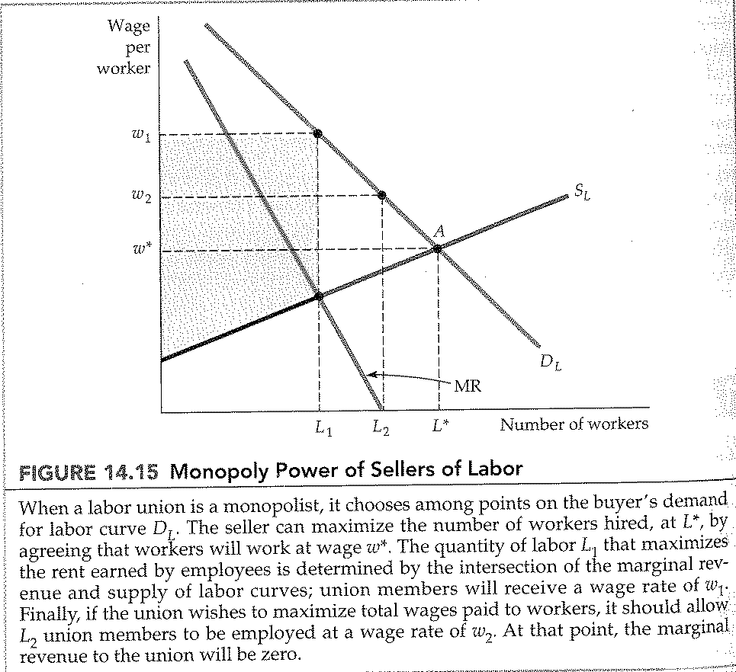
CHAPTER 14: Market for factor inputs
Wage discrimination in unionized and nonunionized sectors
