CHAPTER 4: INDIVIDUAL AND MARKET DEMAND
Checklist

Can you do the following regarding individual and market demand?
- Explain the income effect on consumer equilibrium
- Explain the price effect on consumer equilibrium
- Define normal goods
- Define inferior goods
- What is an Engel curve?
- Explain the substitution effect
- Explain the income effect
- Explain the total effect
- What is a Giffen good?
- Define inelastic demand
- Define elastic demand
- Define isoelastic demand
- Define consumer surplus
- Define network externalities
- Explain the bandwagon effect
- Explain the snob effect

CHAPTER 4: INDIVIDUAL AND MARKET DEMAND
Income effect on consumer equilibrium

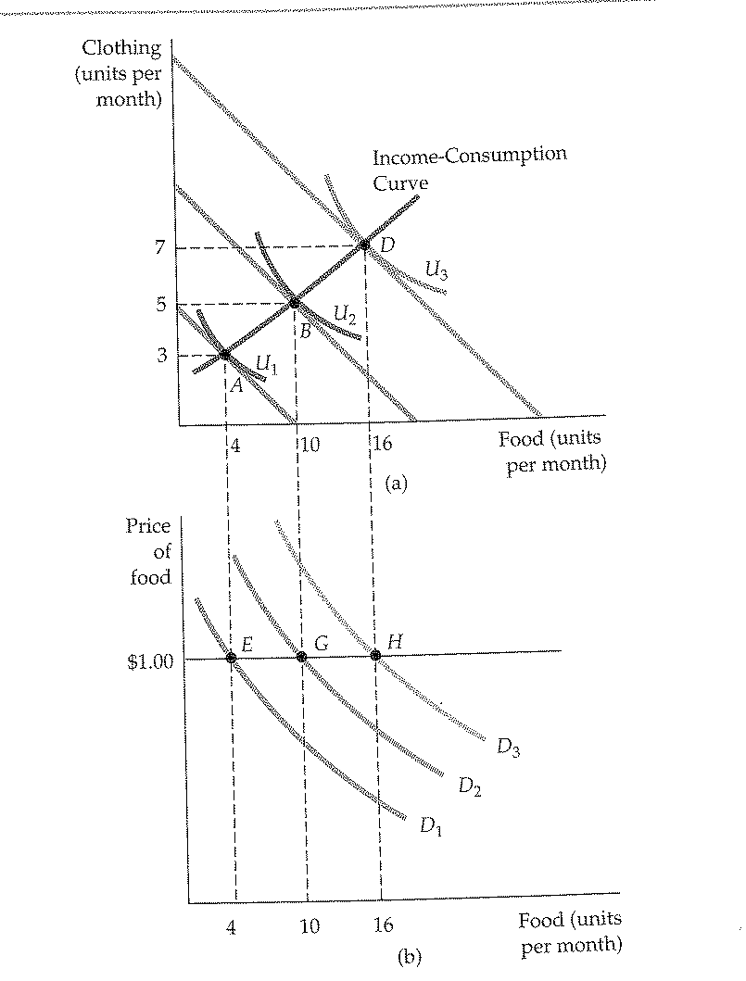

CHAPTER 4: INDIVIDUAL AND MARKET DEMAND
Price effect on consumer equilibrium

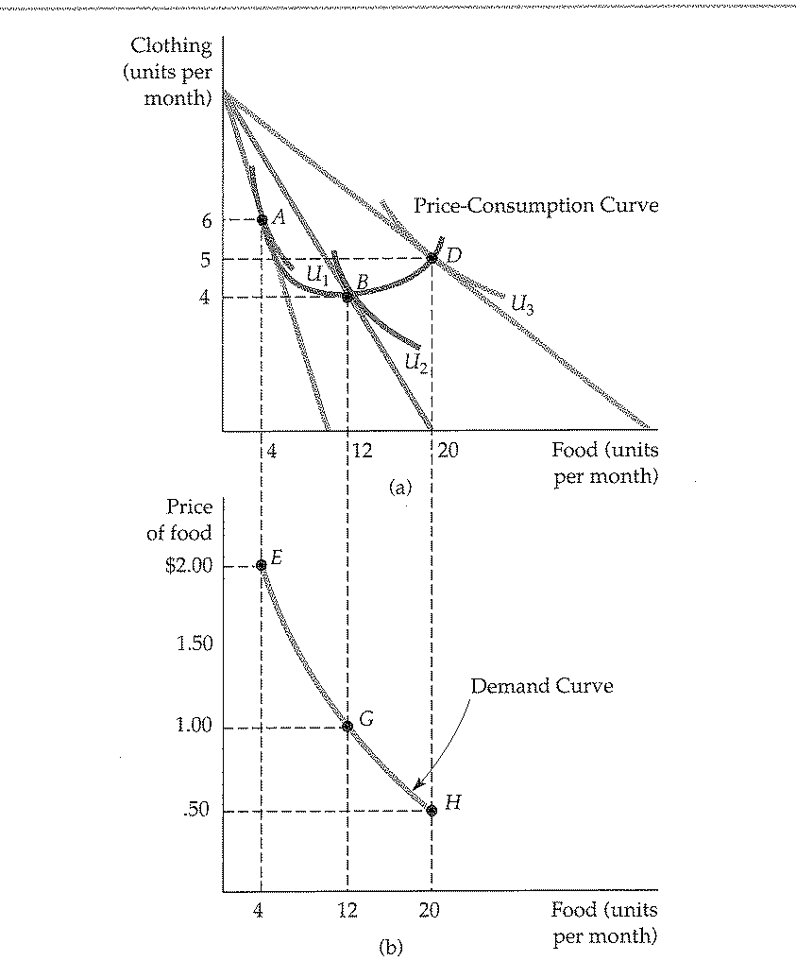

CHAPTER 4: INDIVIDUAL AND MARKET DEMAND
Effect on inferior goods
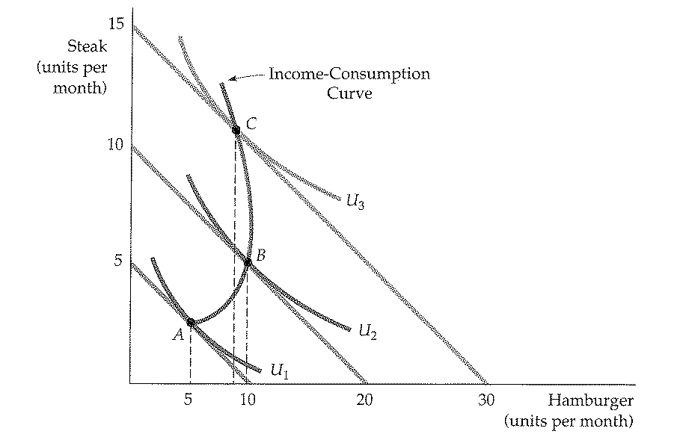

CHAPTER 4: INDIVIDUAL AND MARKET DEMAND
Engel curve
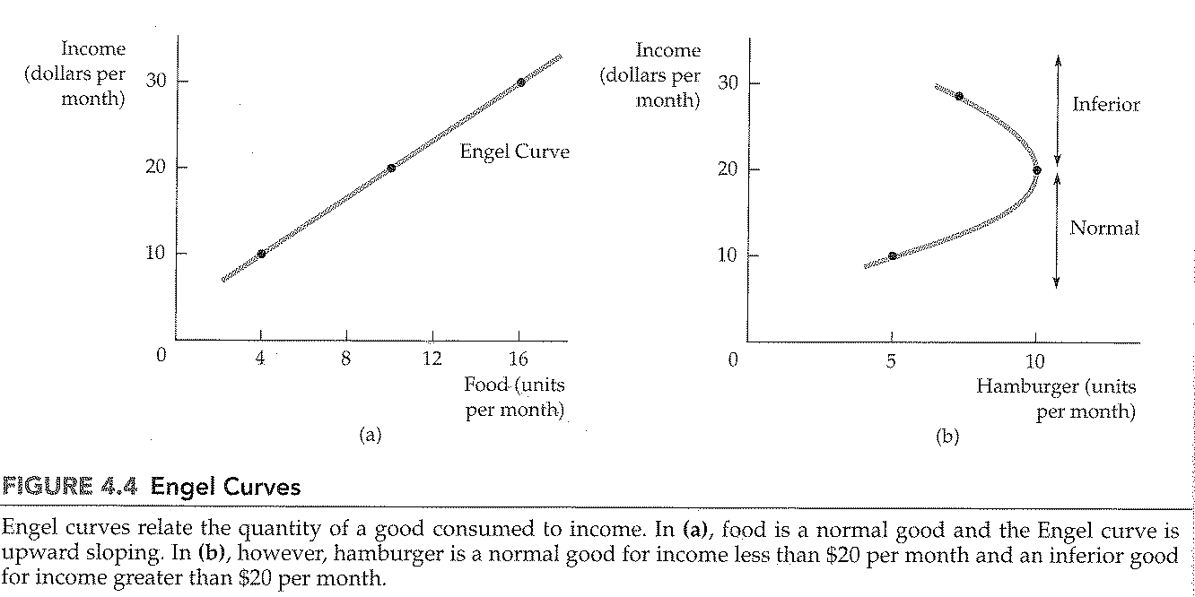
CHAPTER 4: INDIVIDUAL AND MARKET DEMAND
Engel curve

CHAPTER 4: INDIVIDUAL AND MARKET DEMAND
Income and substitution on normal goods
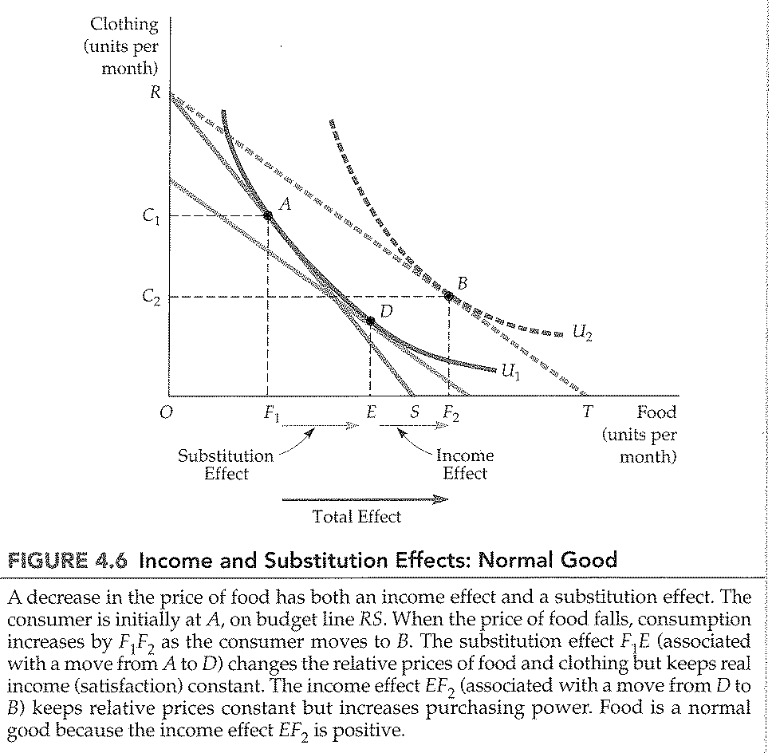

CHAPTER 4: INDIVIDUAL AND MARKET DEMAND
Income and substitution on inferior goods
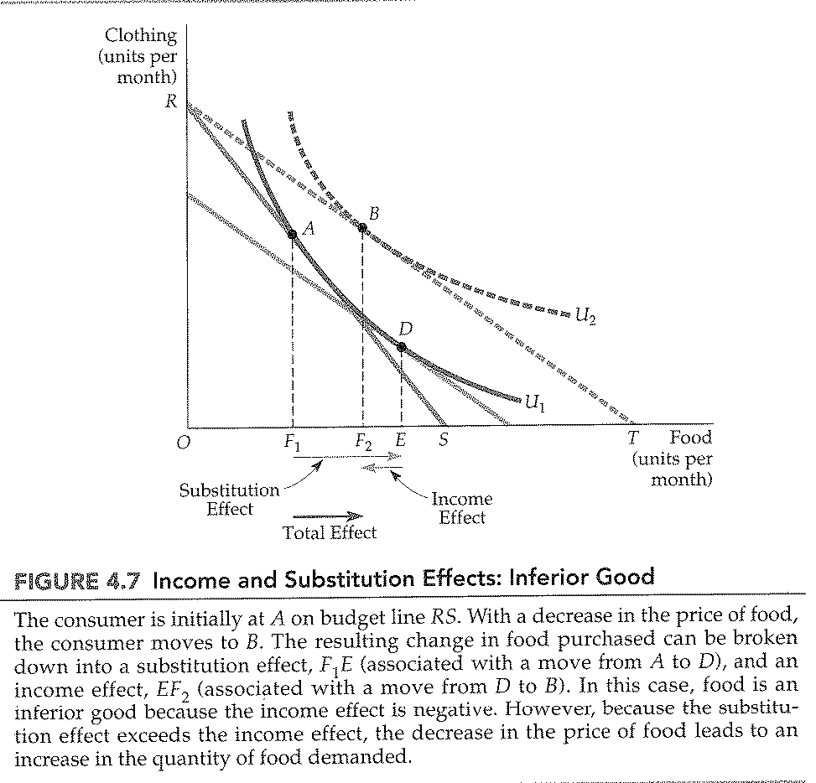

CHAPTER 4: INDIVIDUAL AND MARKET DEMAND
Income and substitution on giffen goods
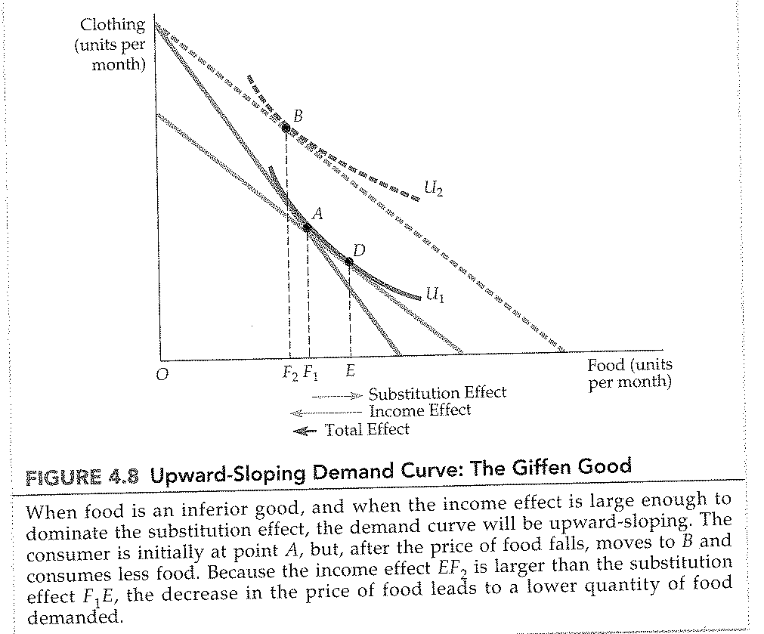

CHAPTER 4: INDIVIDUAL AND MARKET DEMAND
Market demand curve
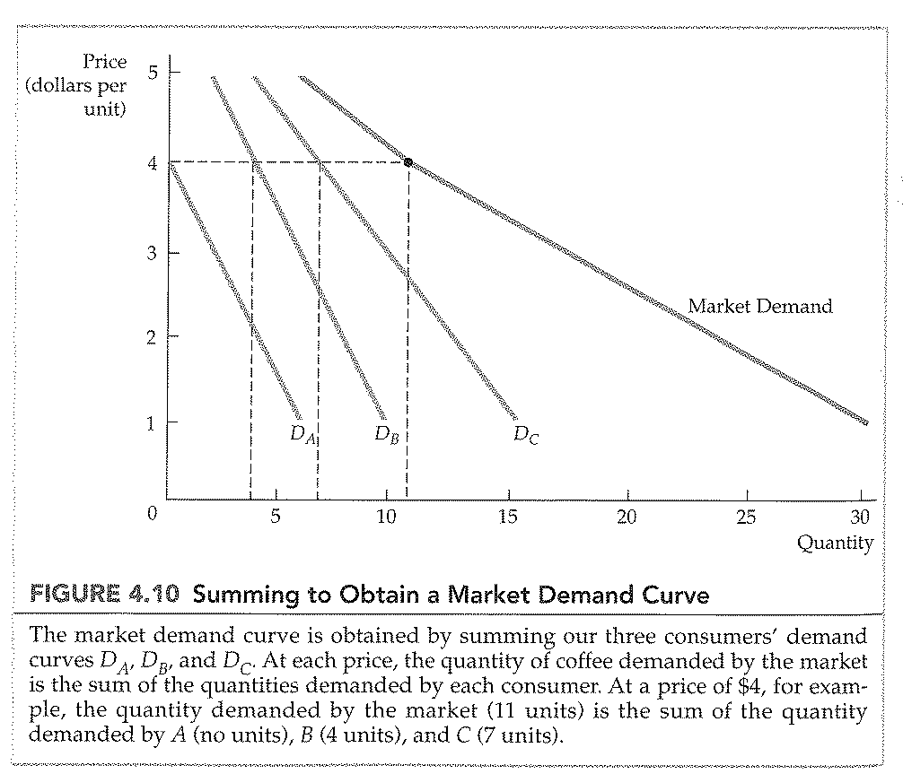

CHAPTER 4: INDIVIDUAL AND MARKET DEMAND
Consumer surplus
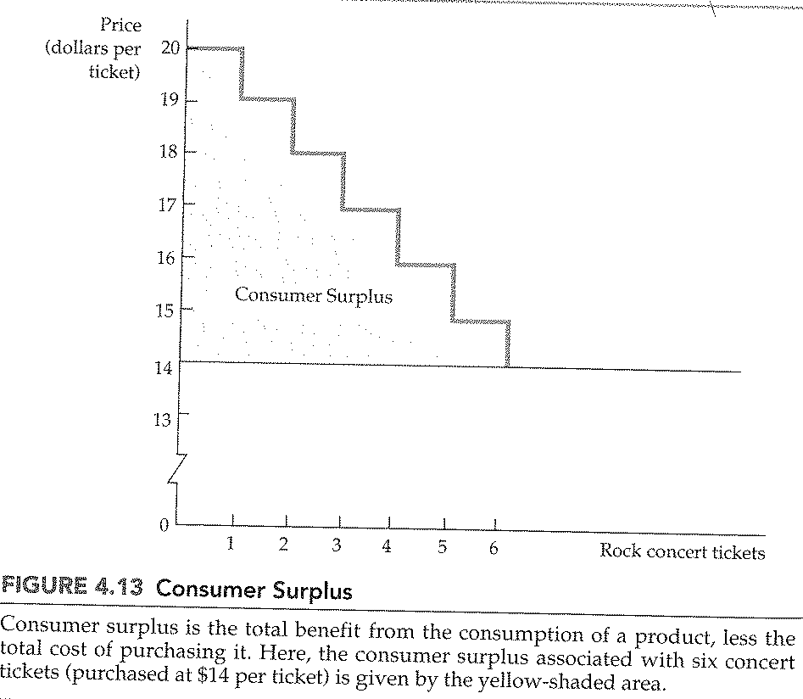

CHAPTER 4: INDIVIDUAL AND MARKET DEMAND
Bandwagon effect
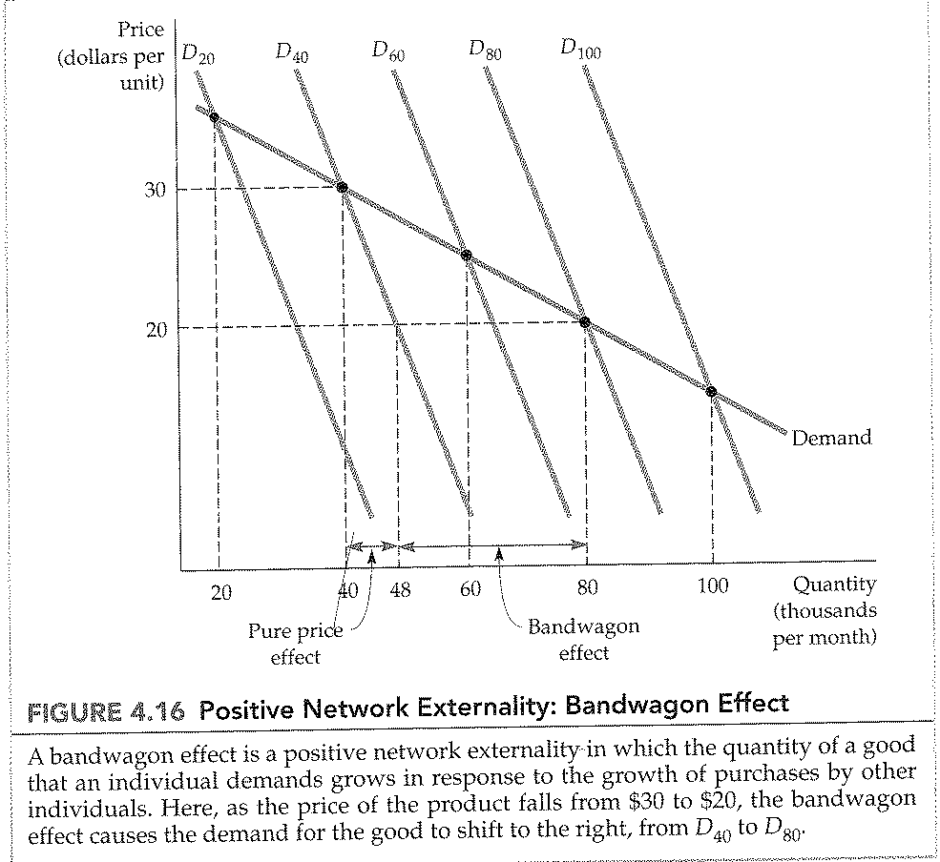
CHAPTER 4: INDIVIDUAL AND MARKET DEMAND
Snob effect
