CHAPTER 6: PRODUCTION
Checklist

Can you do the following regarding production?
- Explain the consumer behavior or purchasing decisions
- Explain the different production decisions
- Define the ‘Theory of the firm’
- What is Factors of Production?
- Define production function
- Formula for the production function
- Difference between short run and long run
- Definition and equation for Marginal product
- Definition and equation for Average product
- Define Law of diminishing marginal returns
- Explain labour productivity
- Define Isoquants
- Define Isoquant map
- Definition and equation for marginal rate of technical substitution (MRTS)
- Define a Fixed-proportion production function/Leonitief production
- Define Isoquant for perfect substitutes
- Define Returns to scale
- Define increasing returns to scale
- Define constant returns to scale
- Define decreasing returns to scale

CHAPTER 6: PRODUCTION
Production function
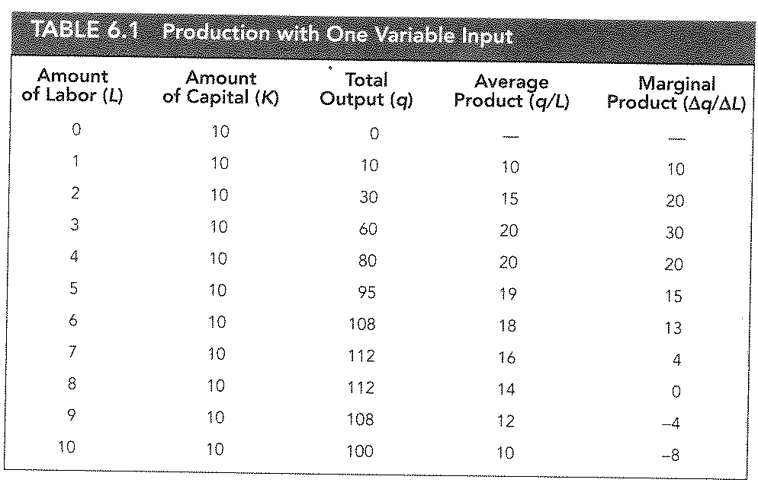
CHAPTER 6: PRODUCTION
Production function with one variable
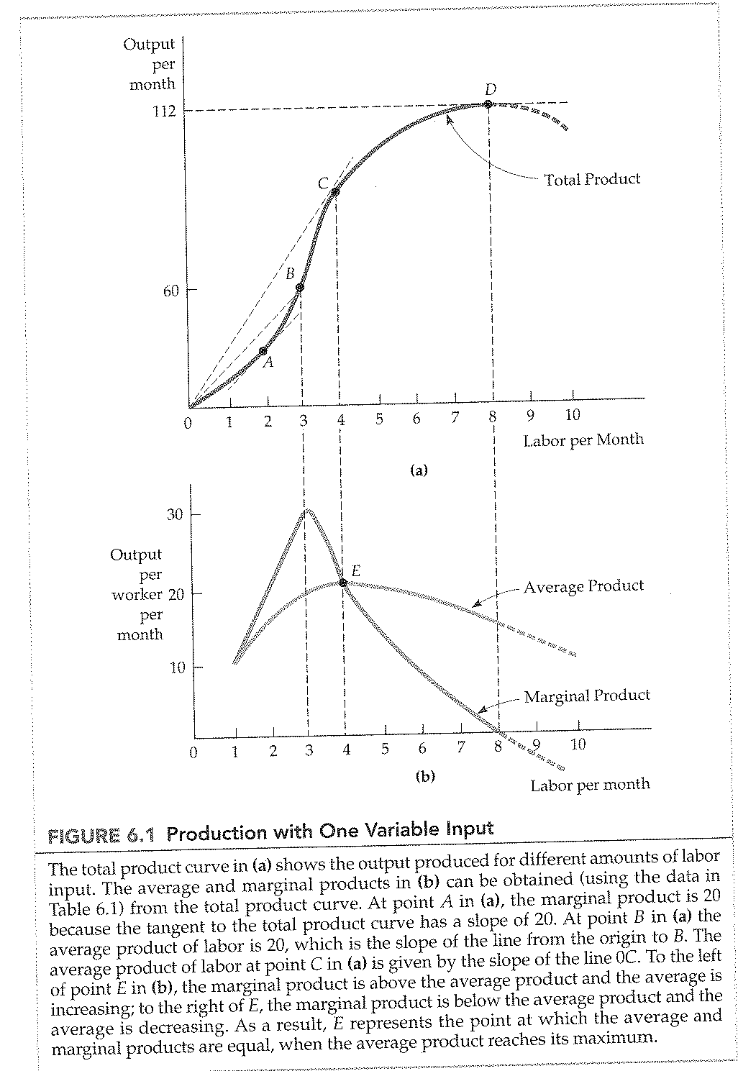
CHAPTER 6: PRODUCTION
Law of diminishing marginal returns
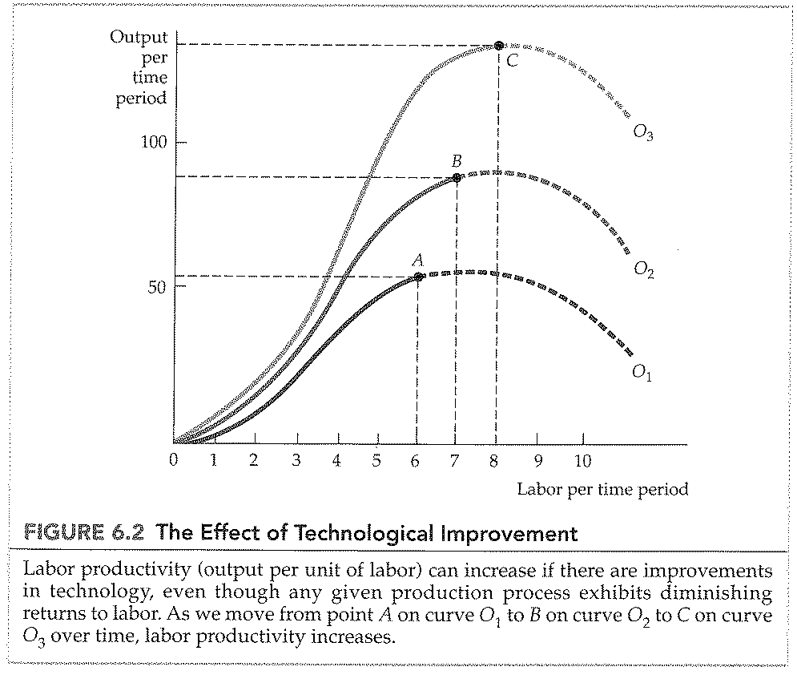

CHAPTER 6: PRODUCTION
Isoquants: Table
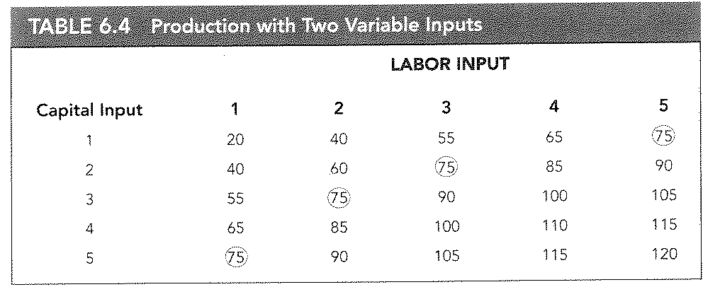

CHAPTER 6: PRODUCTION
Isoquants
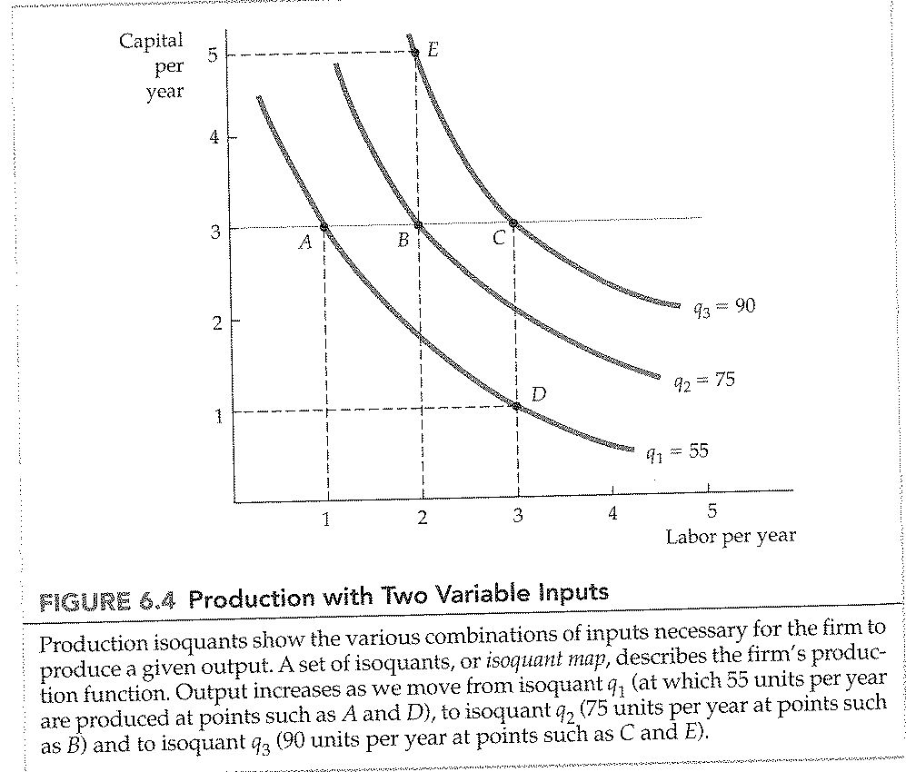

CHAPTER 6: PRODUCTION
Marginal rate of technical substitution (MRTS)
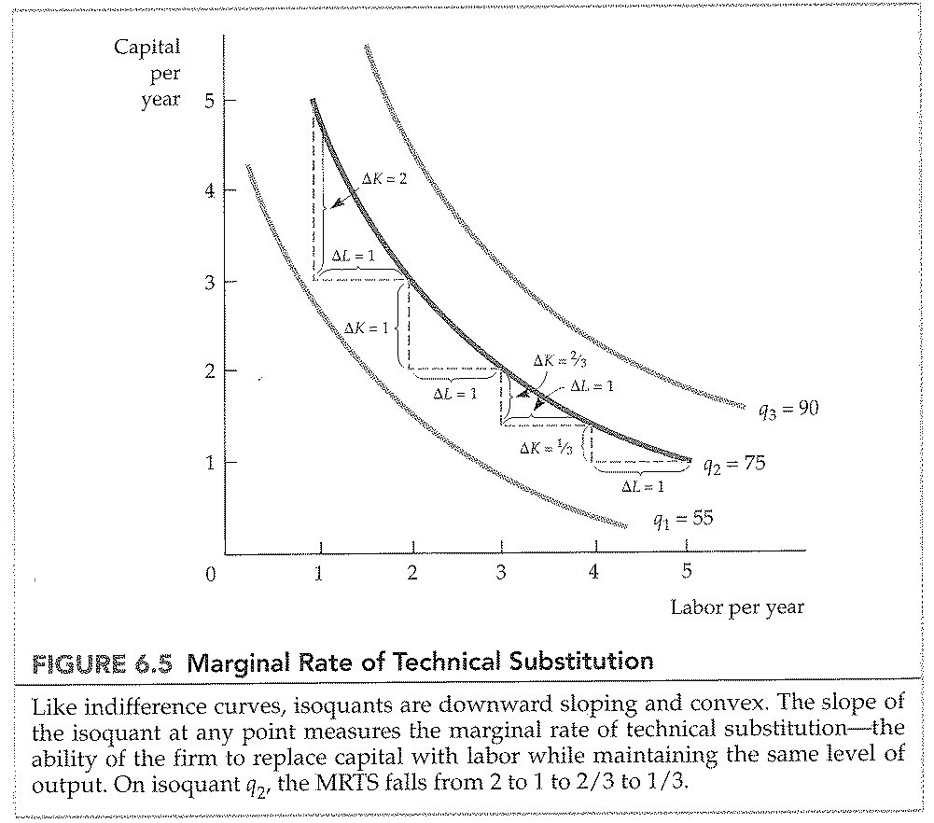

CHAPTER 6: PRODUCTION
Isoquant for perfect substitutes
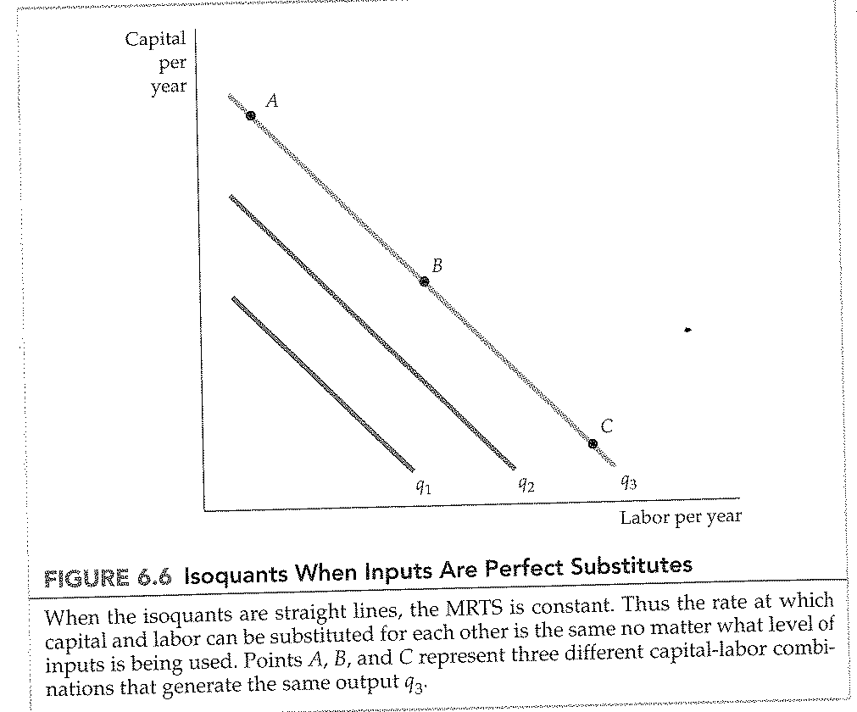
CHAPTER 6: PRODUCTION
Fixed-proportions/Leonitief production function
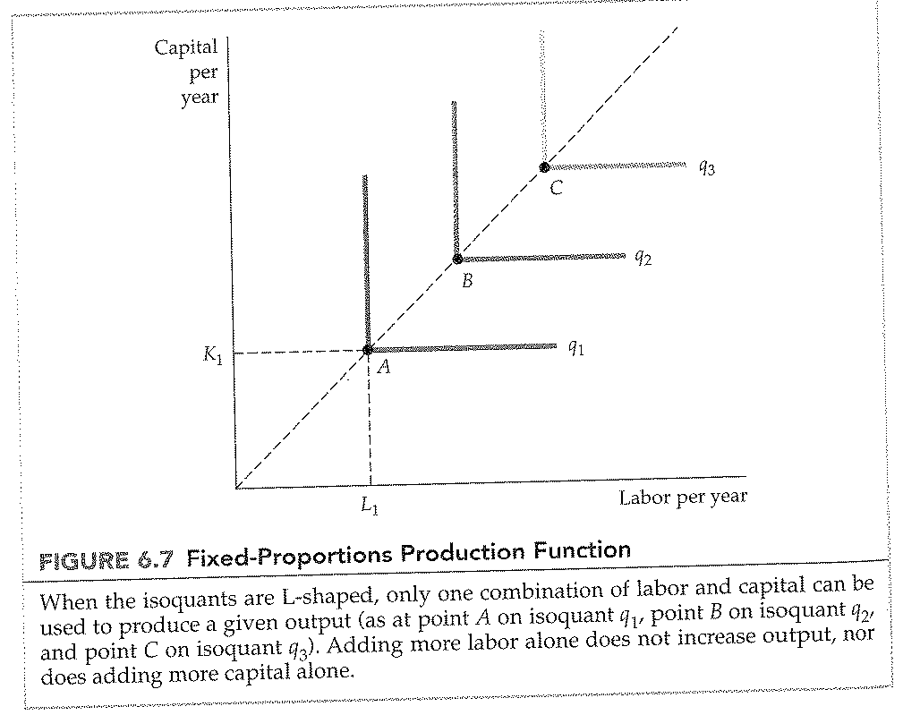

CHAPTER 6: PRODUCTION
Returns to scale
