CHAPTER 7: THE COST OF PRODUCTION
Checklist

Can you do the following regarding cost of production?
- Compare accounting cost to economic cost
- Compare opportunity cost to sunk cost
- Compare fixed cost to variable cost
- What is Total cost?
- Compare marginal cost to average cost
- Define average fixed cost
- Define average variable cost
- Define isoquant
- Define isocost
- What is the price of capital?
- What is the rental rate of capital?
- Define expansion path
- Explain inflexibility of SR production
- Define Economies of scale and diseconomies of scale
- Define Economies of scope and diseconomies of scope
- Define the product transformation curve

CHAPTER 7: COST OF PRODUCTION
A firm’s cost
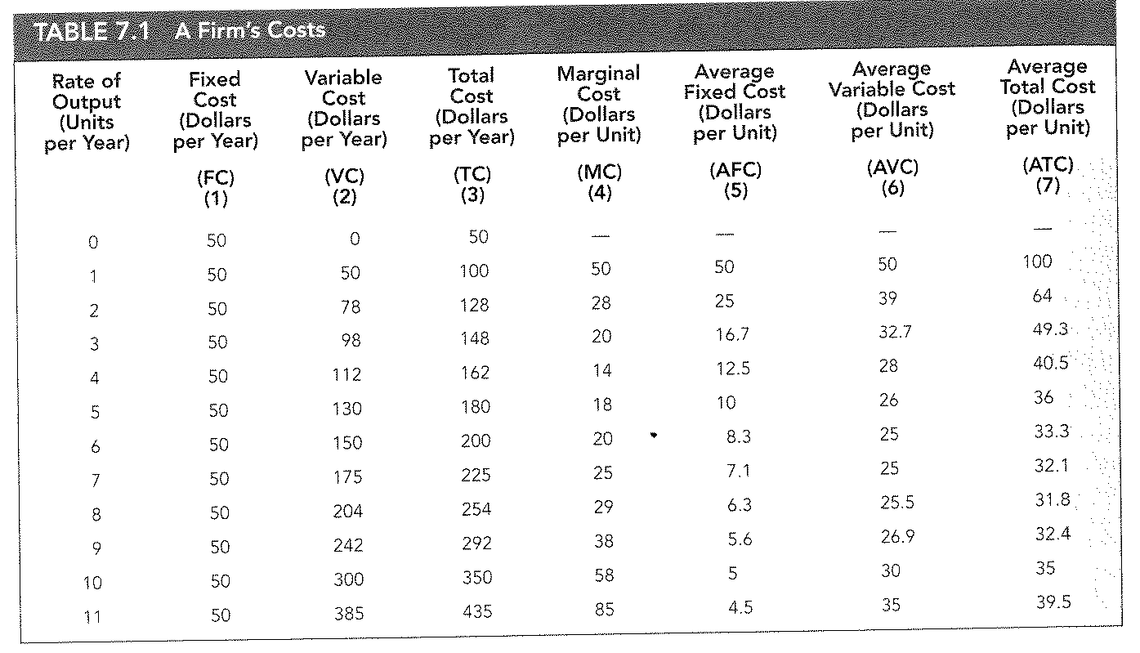

CHAPTER 7: COST OF PRODUCTION
Relationship between production and cost
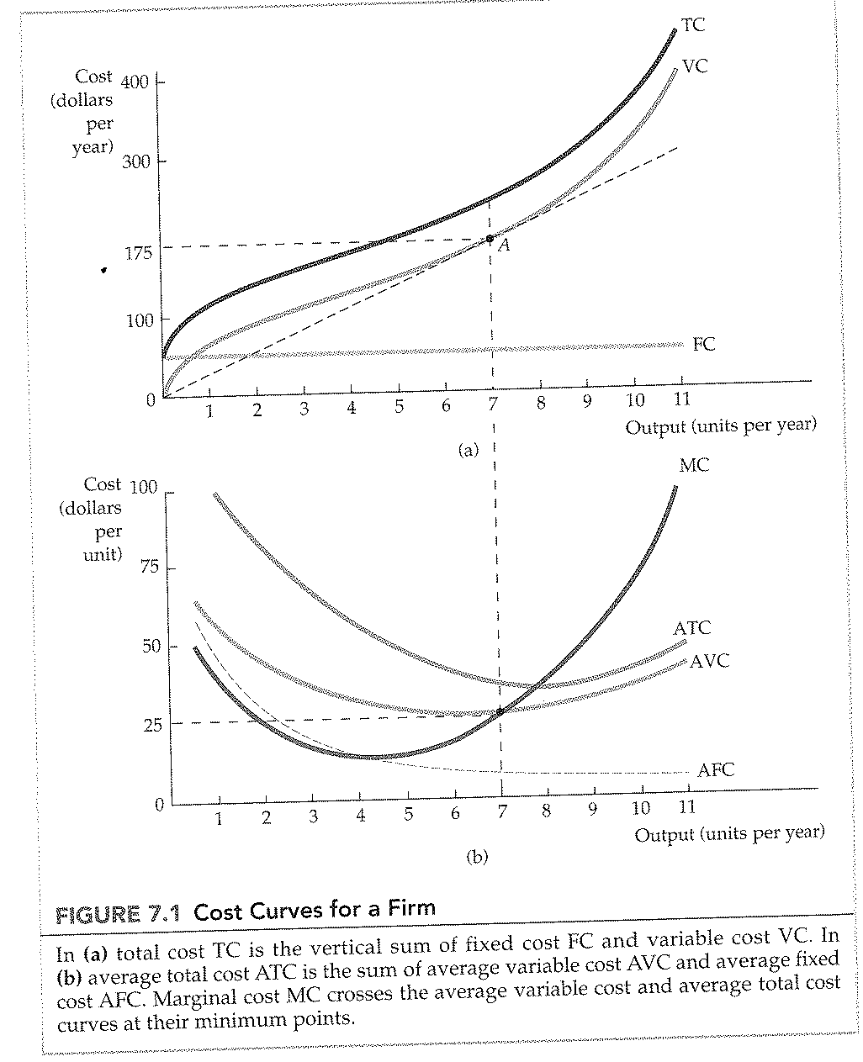

CHAPTER 7: COST OF PRODUCTION
Isoquant and Isocost lines
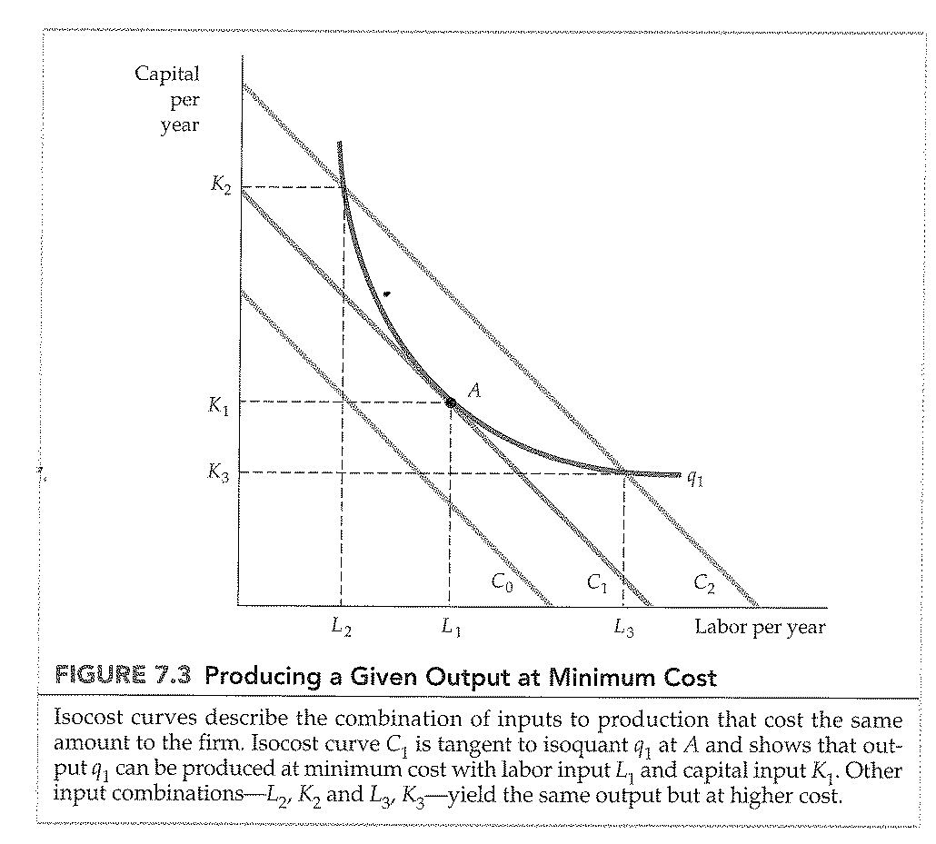

CHAPTER 7: COST OF PRODUCTION
Choosing inputs
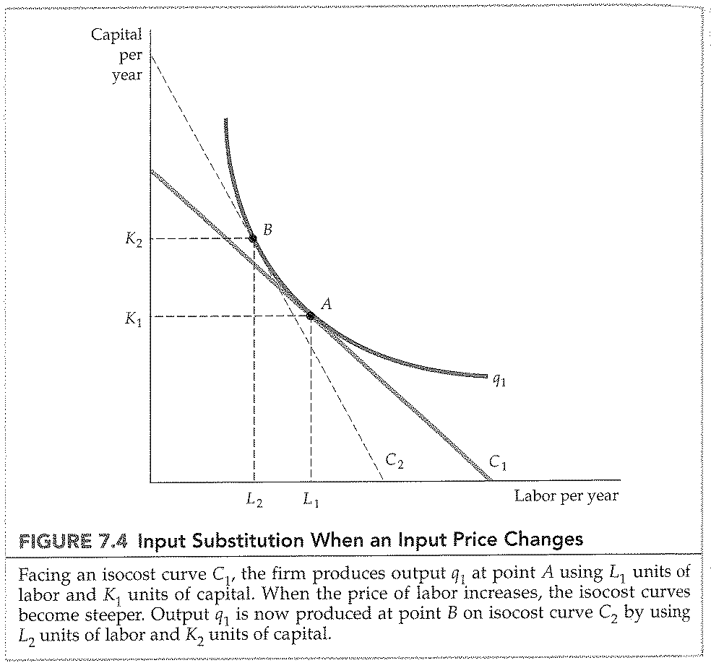

CHAPTER 7: COST OF PRODUCTION
LR and SR Expansion path
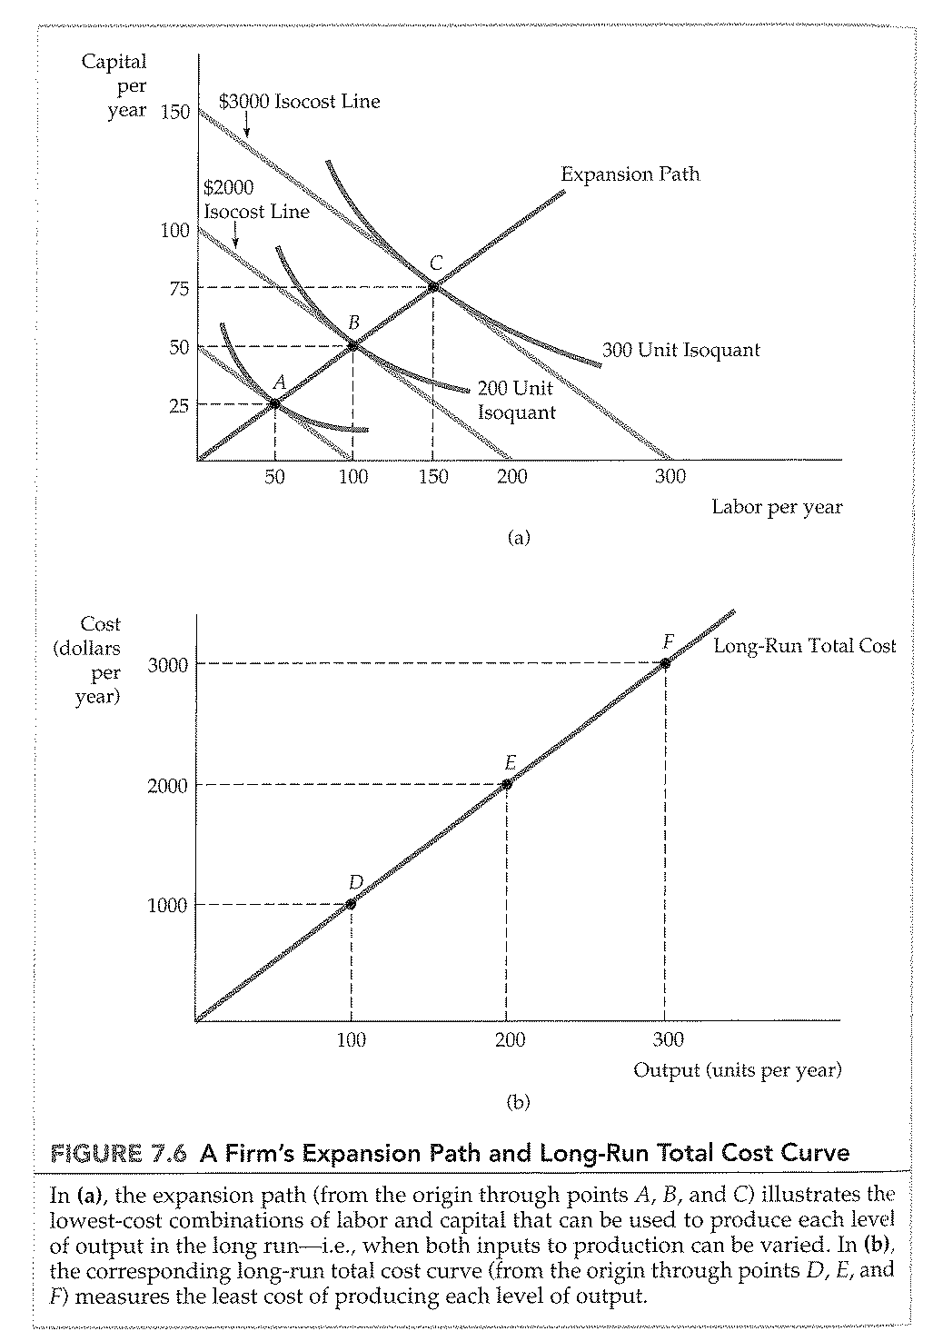

CHAPTER 7: COST OF PRODUCTION
Inflexibility of SR production
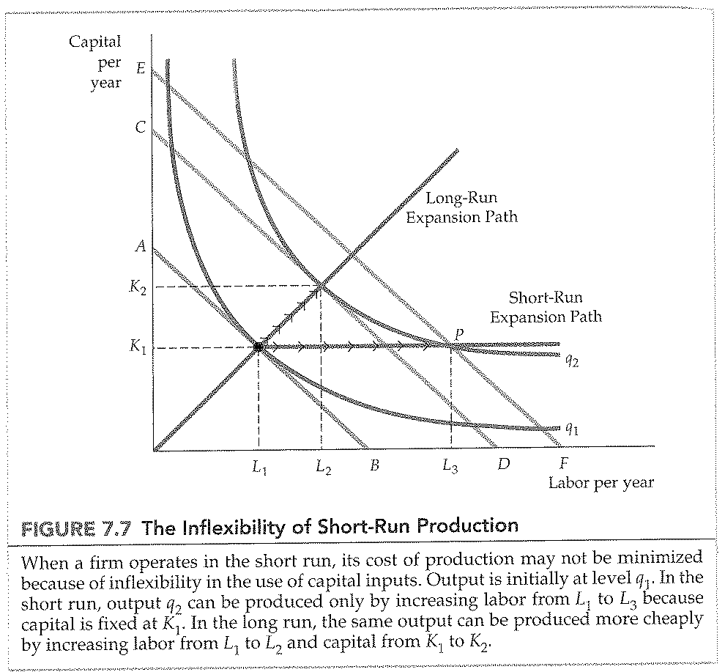

CHAPTER 7: COST OF PRODUCTION
LR and SR cost curves
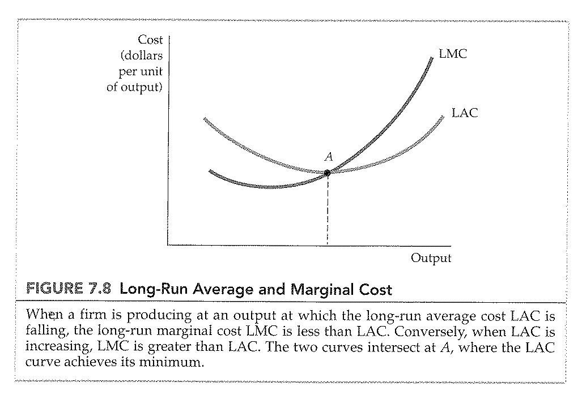
CHAPTER 7: COST OF PRODUCTION
SR vs. LR costs
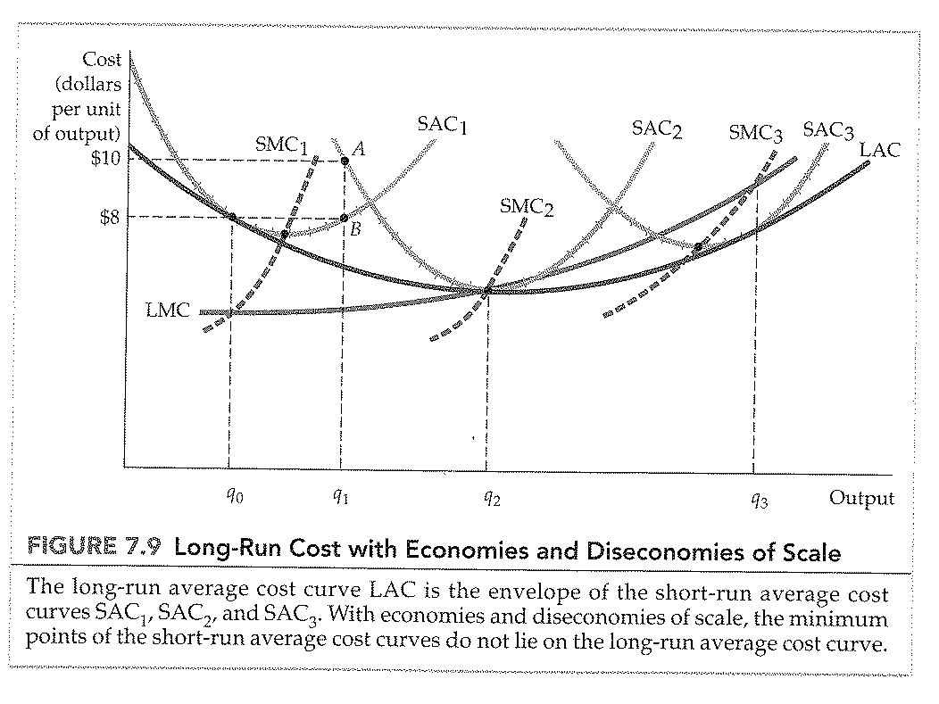

CHAPTER 7: COST OF PRODUCTION
Product Transformation curve
