CHAPTER 8: Profit maximization and Competitive Supply
Checklist

Can you do the following regarding profit and supply?
- Compare the different markets
- Define perfect competition
- Explain the characteristics of perfect competition
- How does profit maximization differ between small and big firms?
- Equation for profit
- Equation for revenue
- Explain profit maximization where MC = MR
- Define supply
- Define supply curve
- Define price elasticity of market supply
- Define producer surplus
- Explain the difference between surplus and profit
- Explain LR competitive equilibrium
- Define economic rent
- Define constant cost industry
- Define increasing cost industry
- Define decreasing cost industry
- Explain what is the effects of tax on output

CHAPTER 8: Profit maximization and Competitive Supply
MR, MC and profit maximization
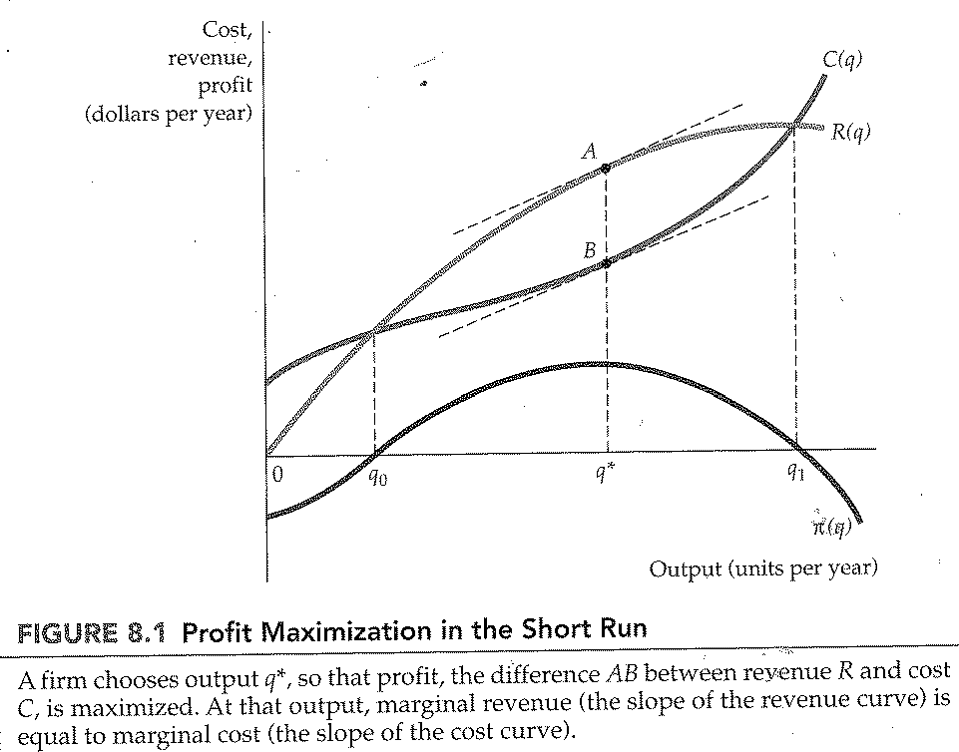
CHAPTER 8: Profit maximization and Competitive Supply
Demand curved faced by a competitive firm
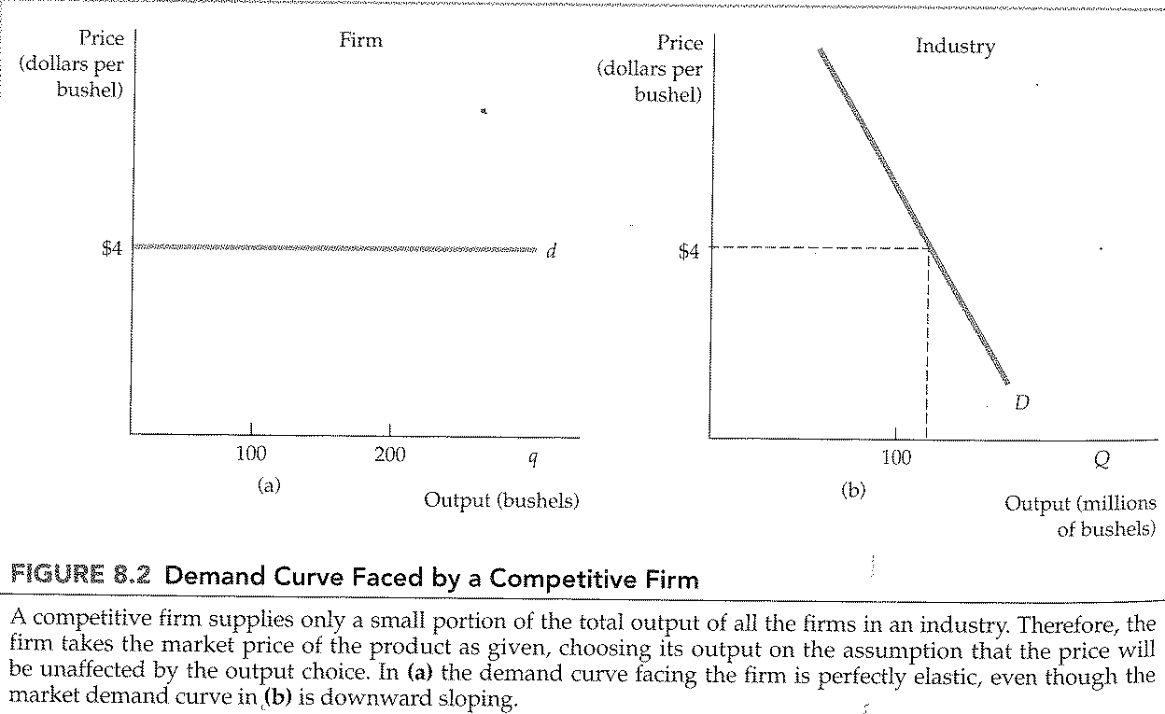

CHAPTER 8: Profit maximization and Competitive Supply
A competitive firm making a positive profit
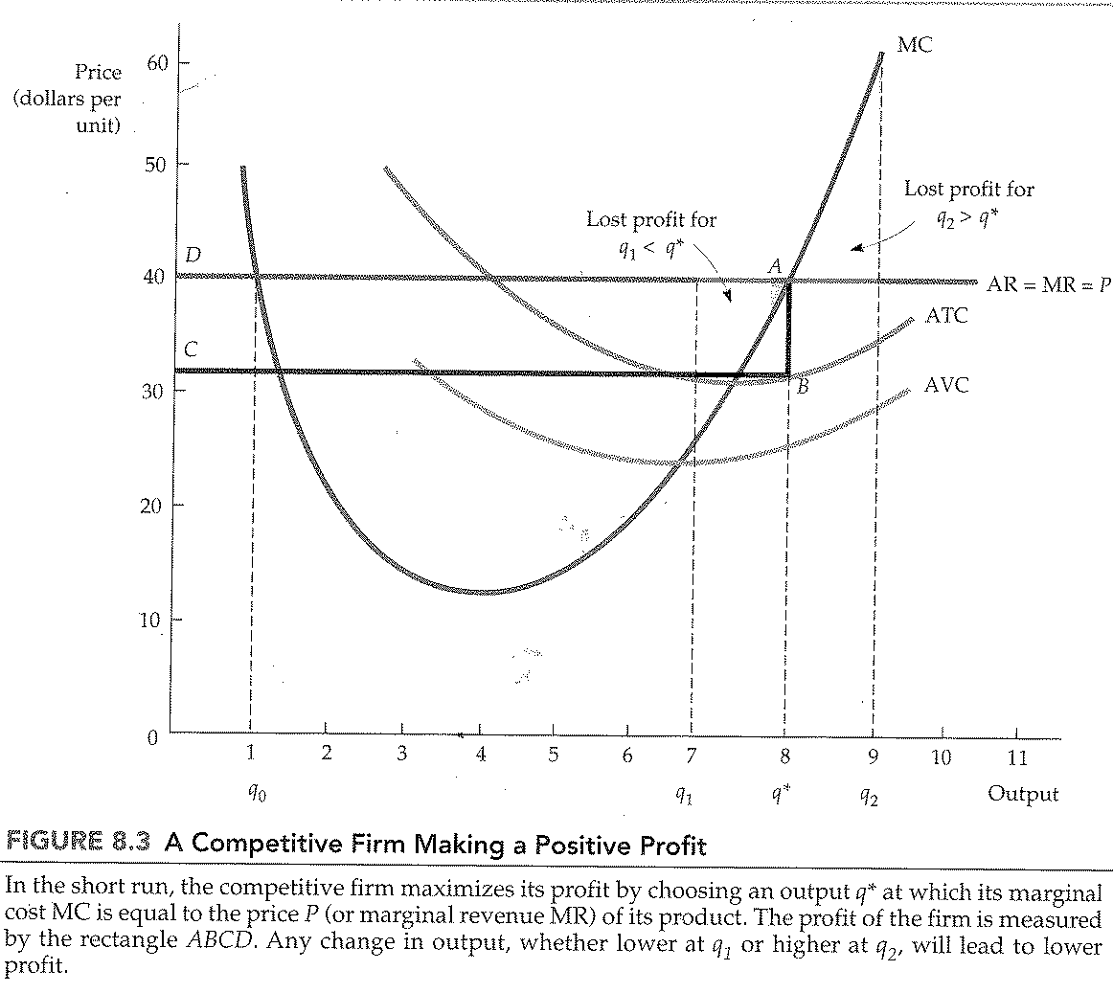

CHAPTER 8: Profit maximization and Competitive Supply
A competitive firm incurring losses
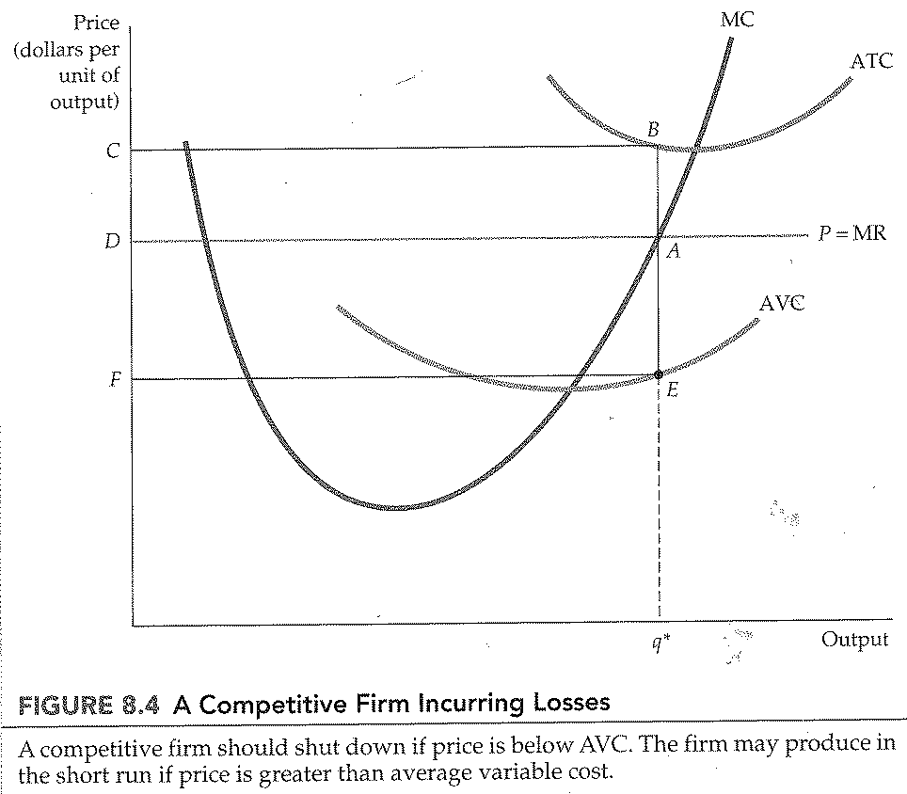

CHAPTER 8: Profit maximization and Competitive Supply
The SR supply curve for a competitive firm
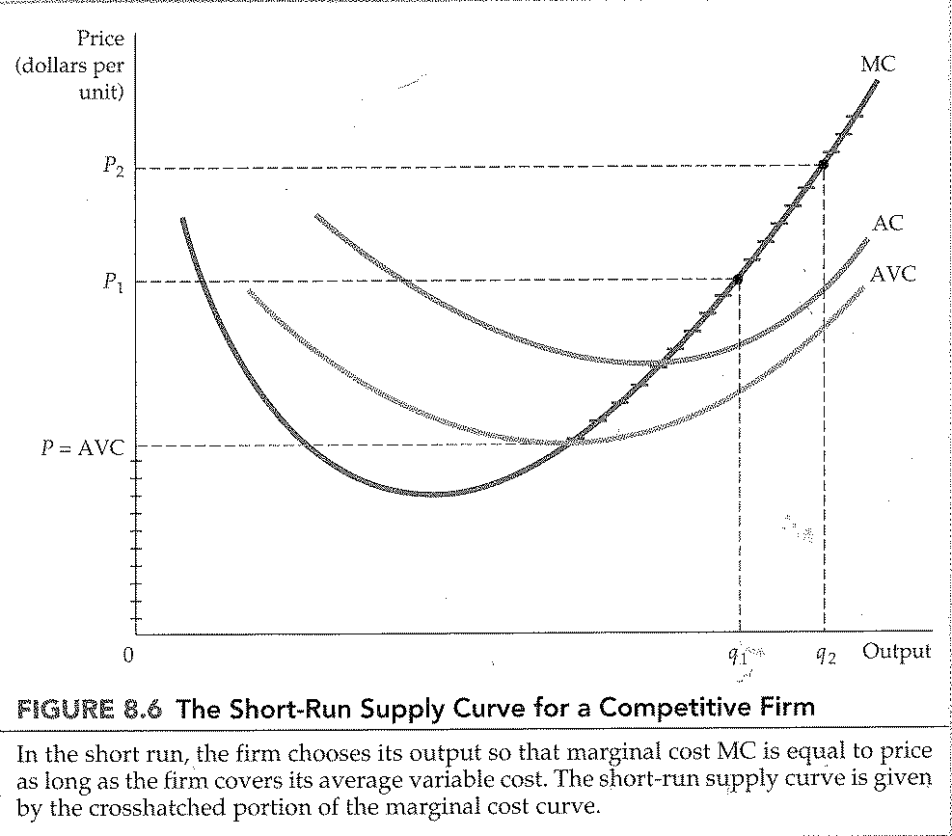

CHAPTER 8: Profit maximization and Competitive Supply
The response of the firm to a change in input price
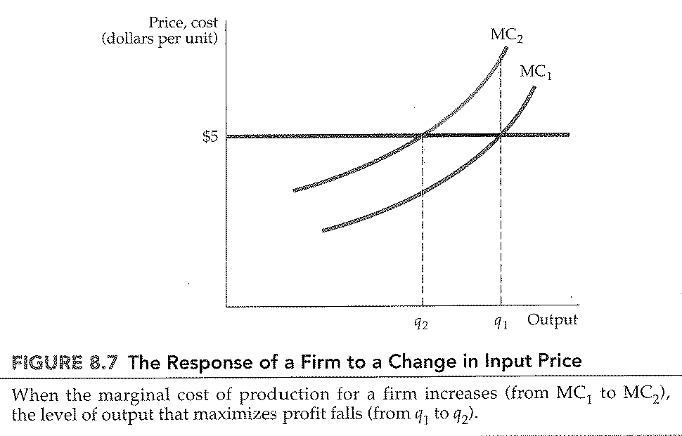
CHAPTER 8: Profit maximization and Competitive Supply
SR industry supply curve
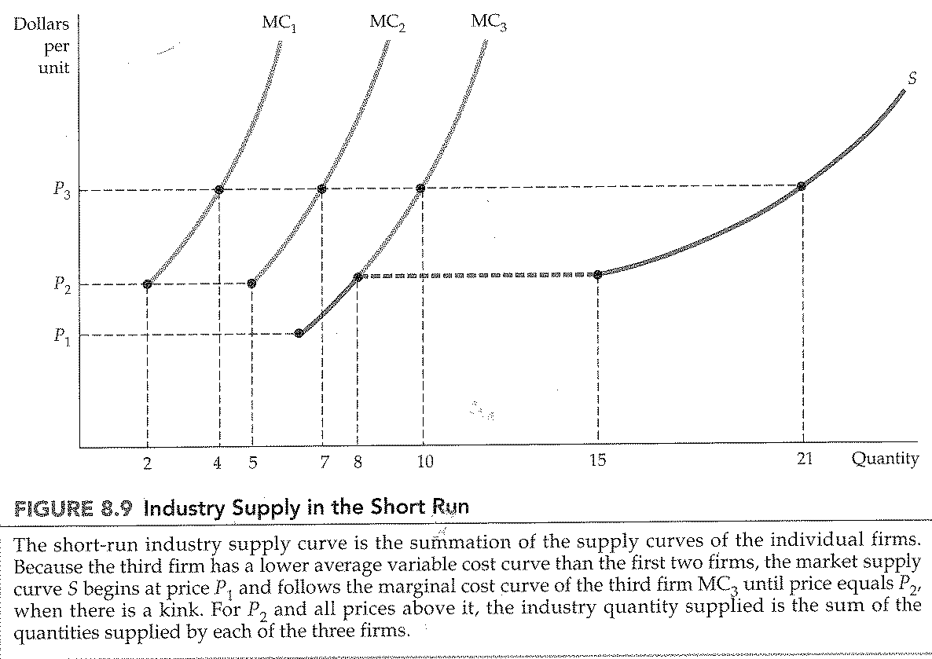

CHAPTER 8: Profit maximization and Competitive Supply
Producer surplus for a firm
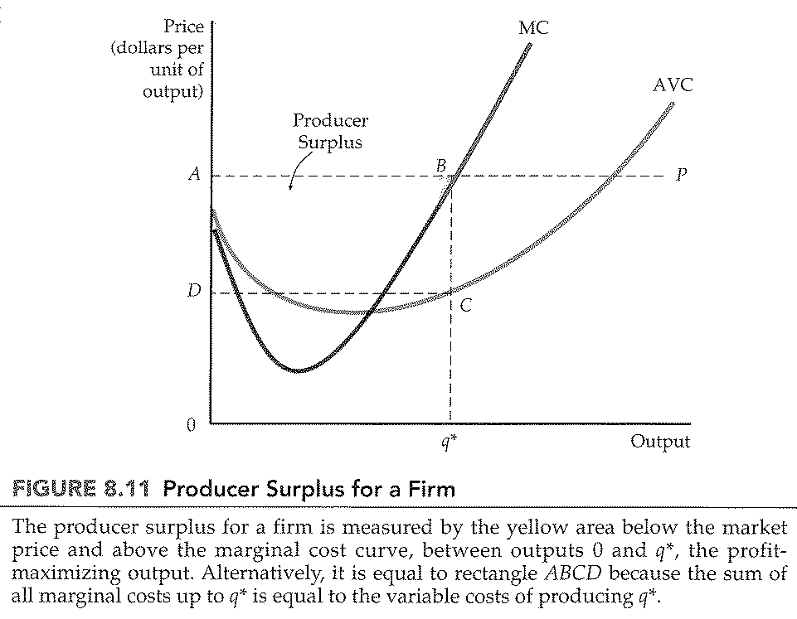
CHAPTER 8: Profit maximization and Competitive Supply
Producer surplus for a market
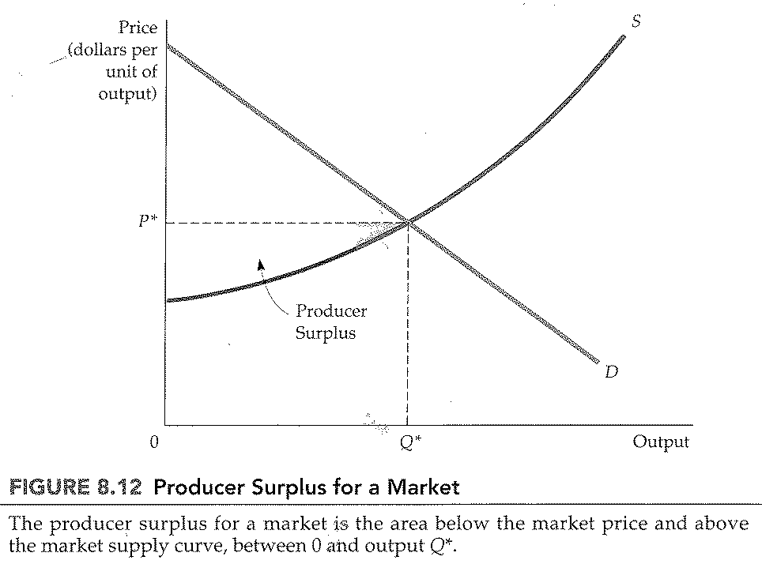

CHAPTER 8: Profit maximization and Competitive Supply
Output choice in the long run
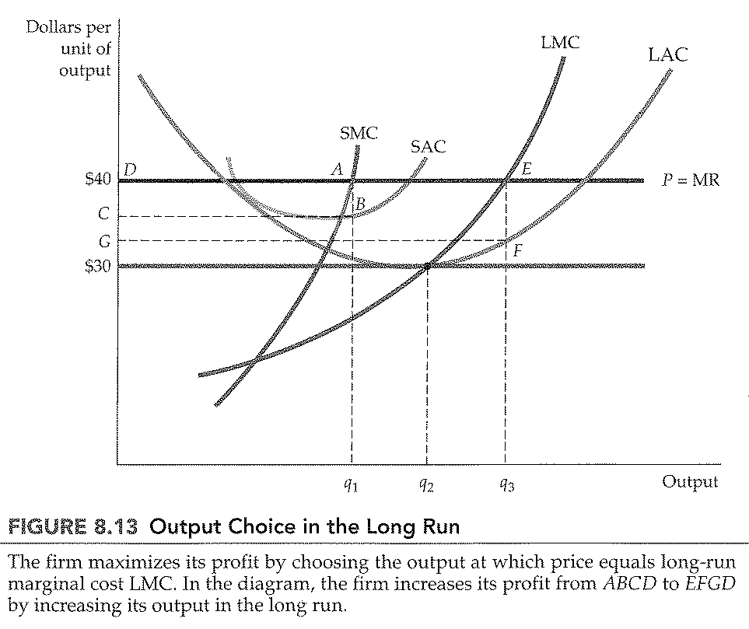

CHAPTER 8: Profit maximization and Competitive Supply
Long run competitive equilibrium
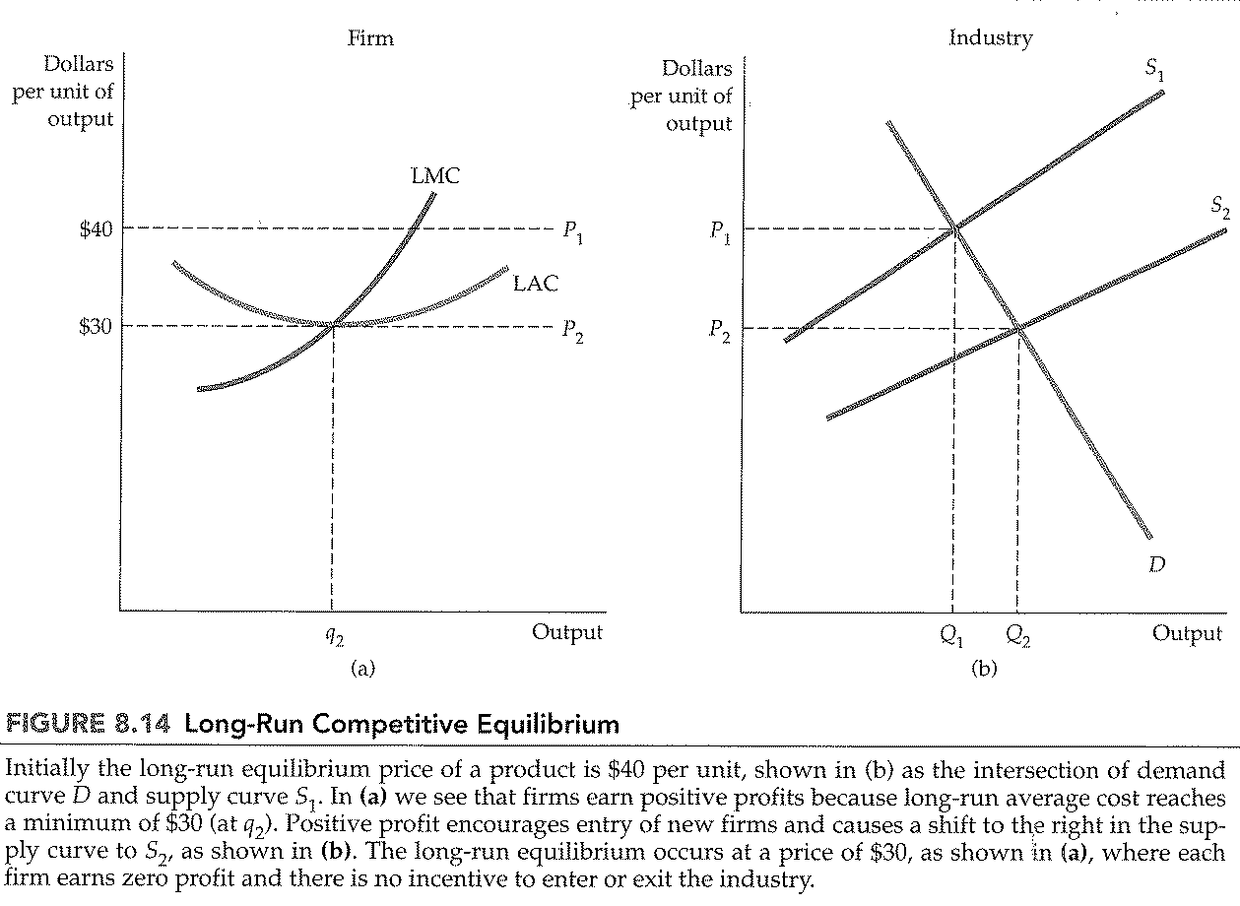
CHAPTER 8: Profit maximization and Competitive Supply
Firms earn zero profit in long run equilibrium
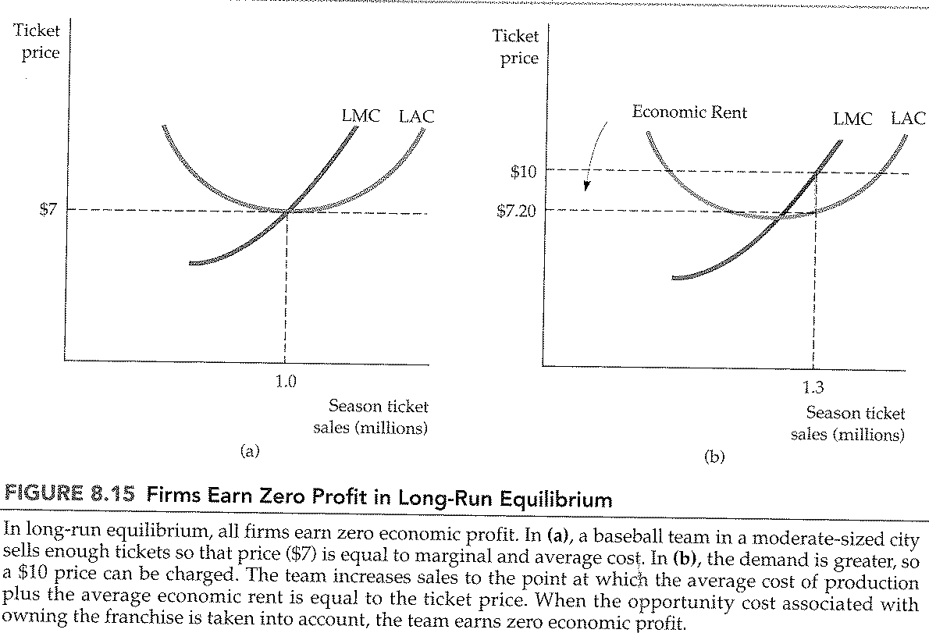
CHAPTER 8: Profit maximization and Competitive Supply
LR supply in constant cost industry
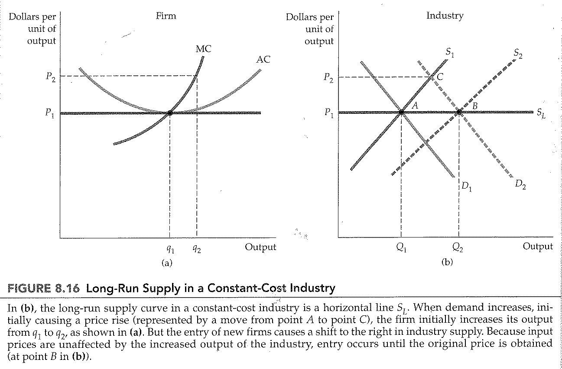
CHAPTER 8: Profit maximization and Competitive Supply
LR supply in an increasing cost industry
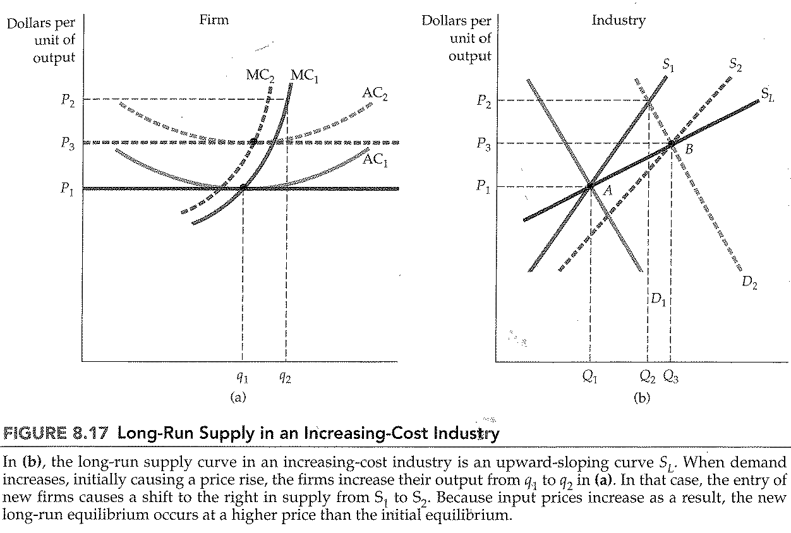
CHAPTER 8: Profit maximization and Competitive Supply
Effects of an output tax on a competitive firm’s output
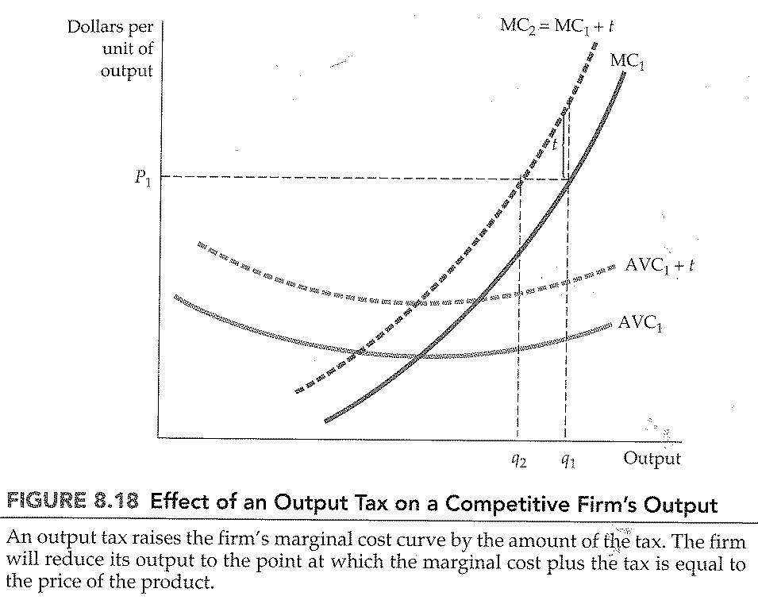
CHAPTER 8: Profit maximization and Competitive Supply
Effect of an output tax on industry output
