CHAPTER 9: The analysis of competitive markets
Checklist

Can you do the following regarding analysis of competitive market?
- Define welfare effects
- Define ceiling price
- Explain consumer surplus
- Explain producer surplus
- Explain deadweight loss
- Explain market failure
- Define externalities
- Define lack of information
- Define minimum price
- Define production quotas
- Define incentive programmes
- Define import quota
- Define tariff
- Define specific tax
- Define and explain the effects of a subsidy

CHAPTER 9: The analysis of competitive markets
Consumer and Producer Surplus
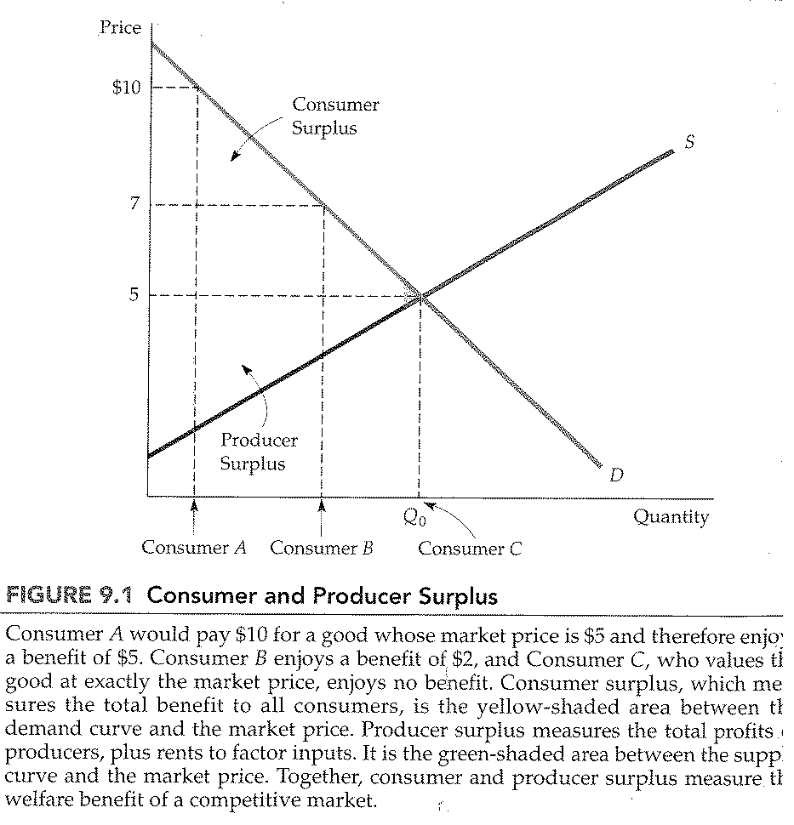
CHAPTER 9: The analysis of competitive markets
Change in consumer and producer surplus from price controls
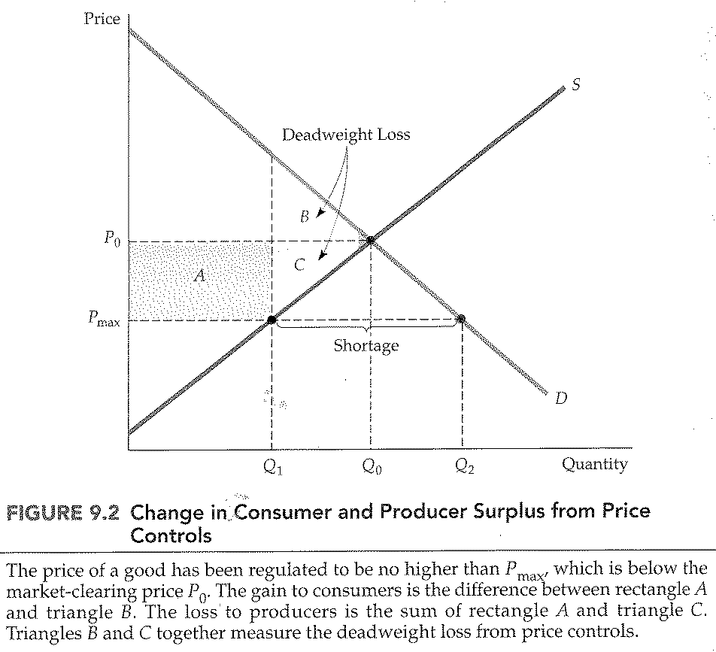

CHAPTER 9: The analysis of competitive markets
Effect of price controls when demand is inelastic
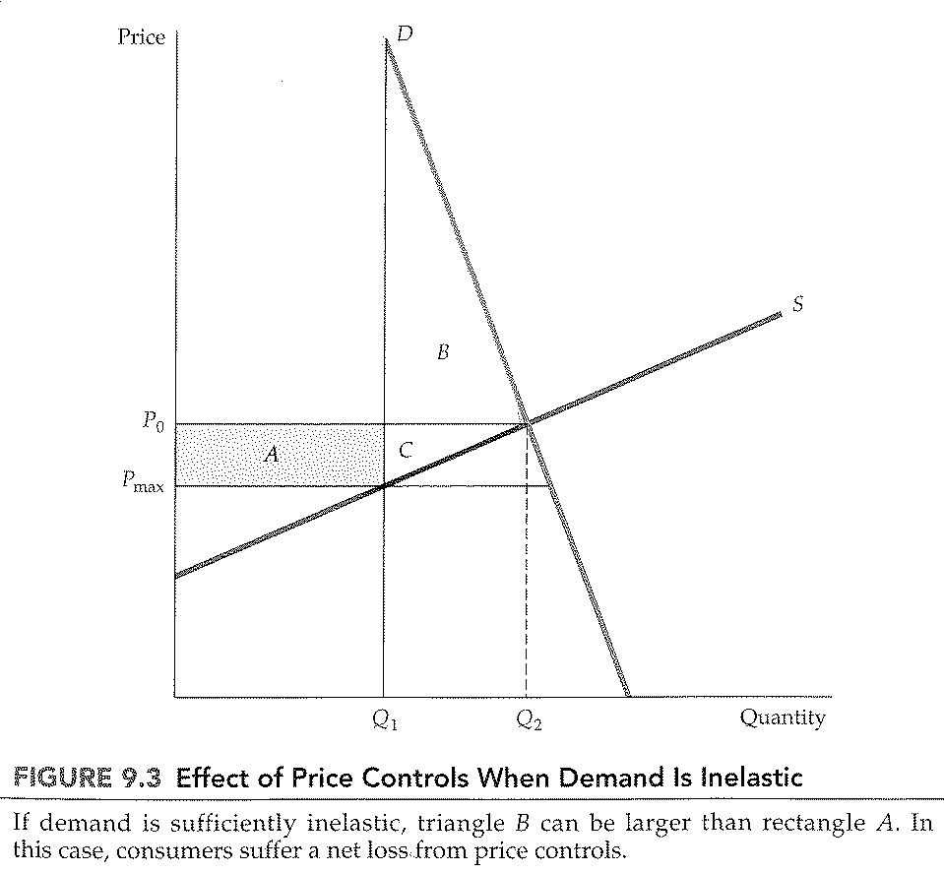

CHAPTER 9: The analysis of competitive markets
Welfare loss when price is held above market-clearing level
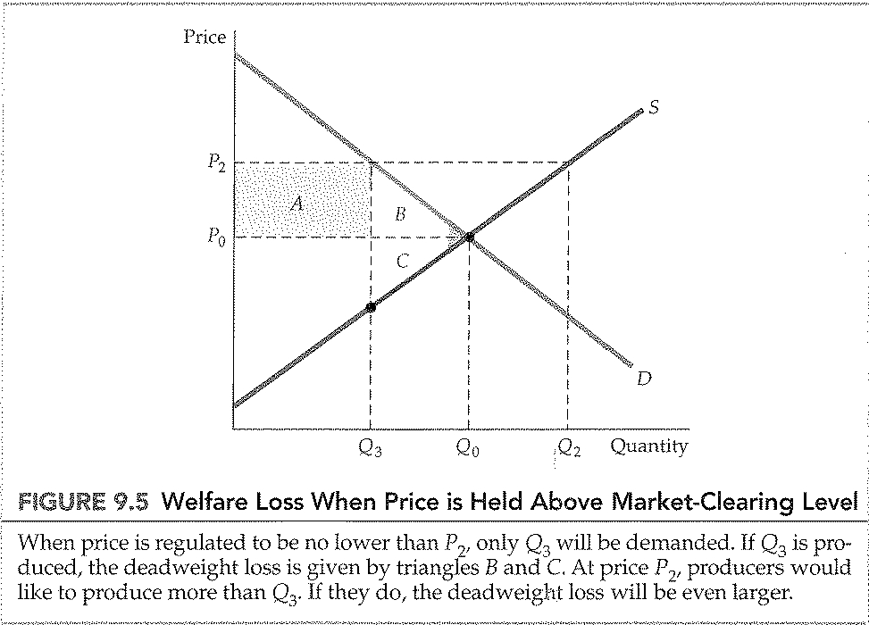

CHAPTER 9: The analysis of competitive markets
Minimum price
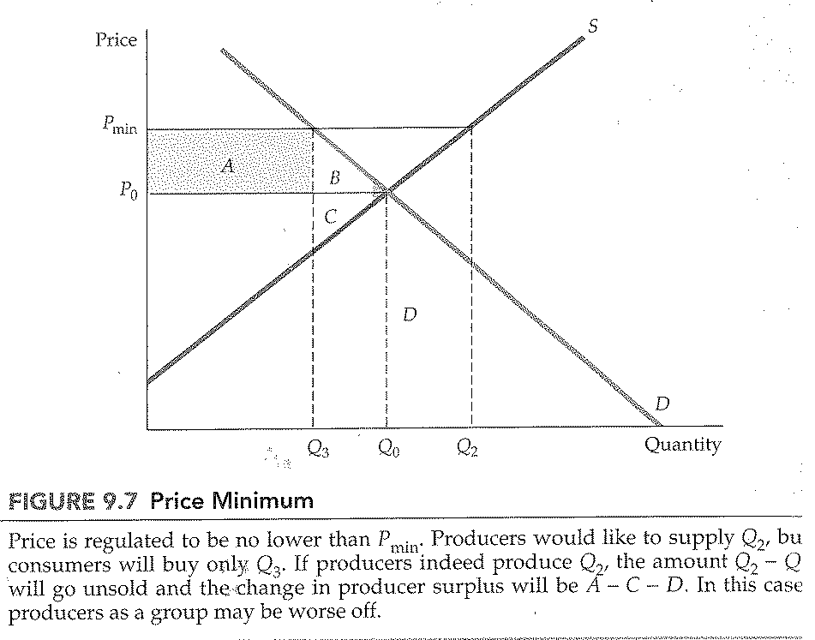
CHAPTER 9: The analysis of competitive markets
Price supports
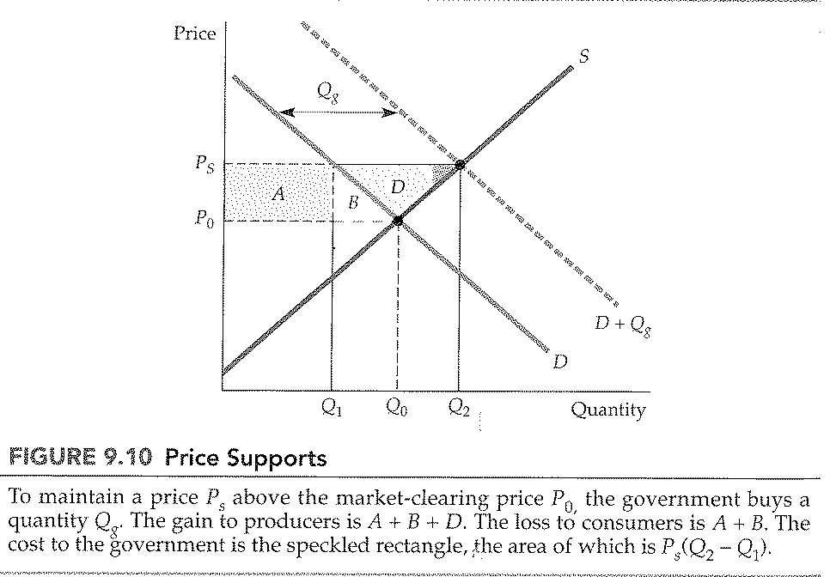
CHAPTER 9: The analysis of competitive markets
Production/Supply restrictions
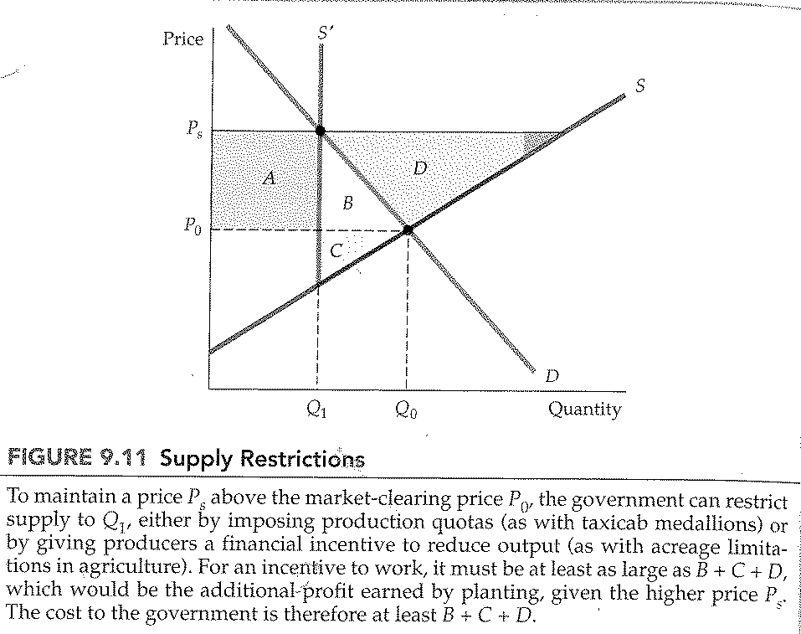

CHAPTER 9: The analysis of competitive markets
Import tariff or Quota that eliminates imports
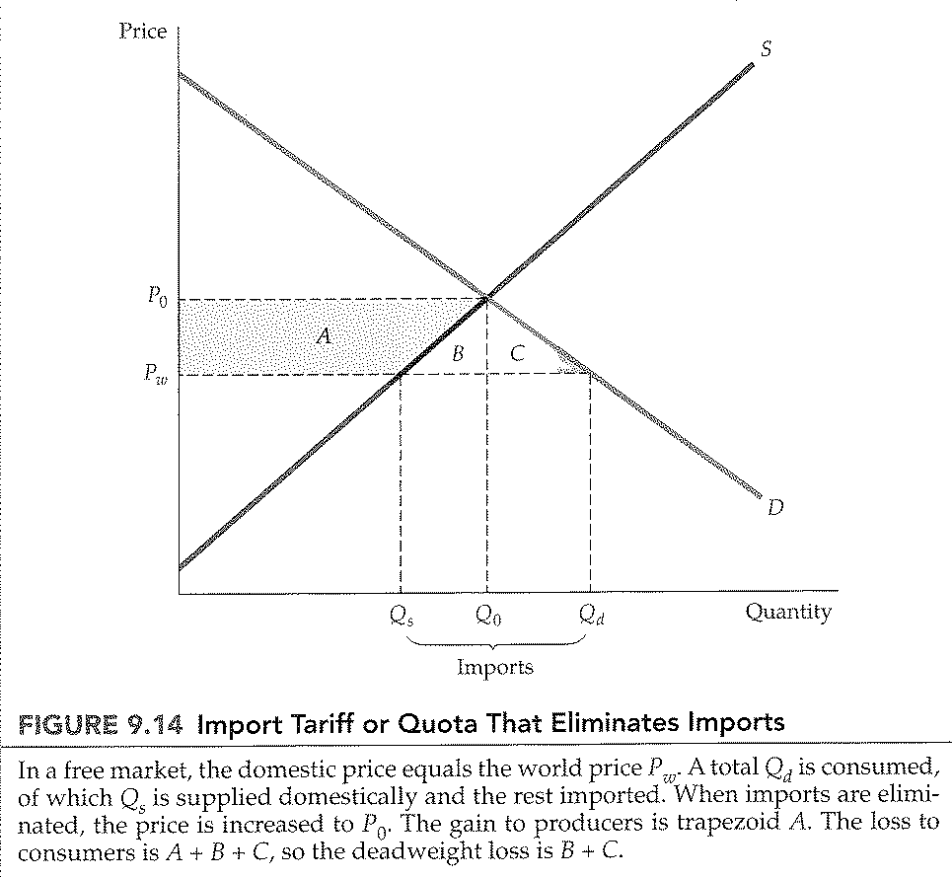

CHAPTER 9: The analysis of competitive markets
Import tariff or quota (General case)
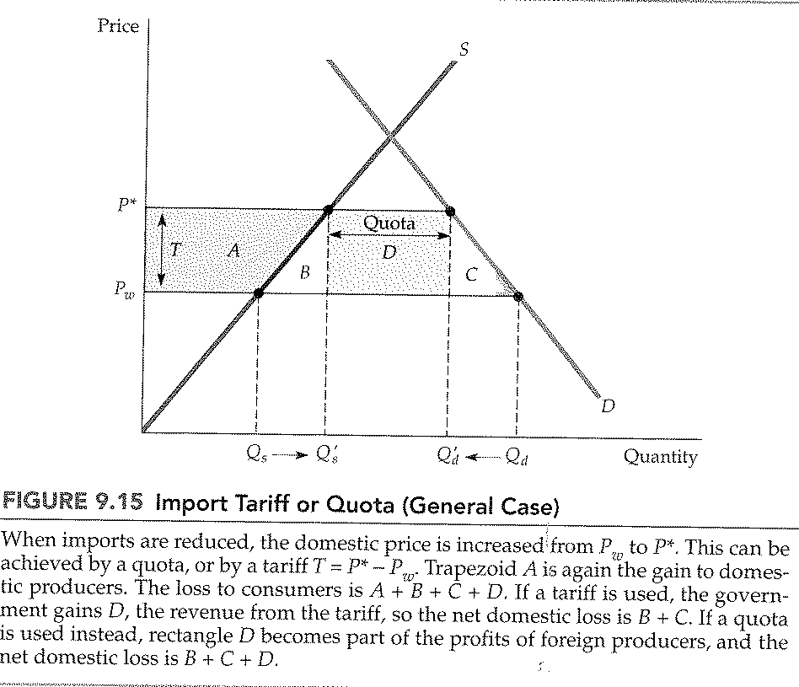

CHAPTER 9: The analysis of competitive markets
Incidence of a tax
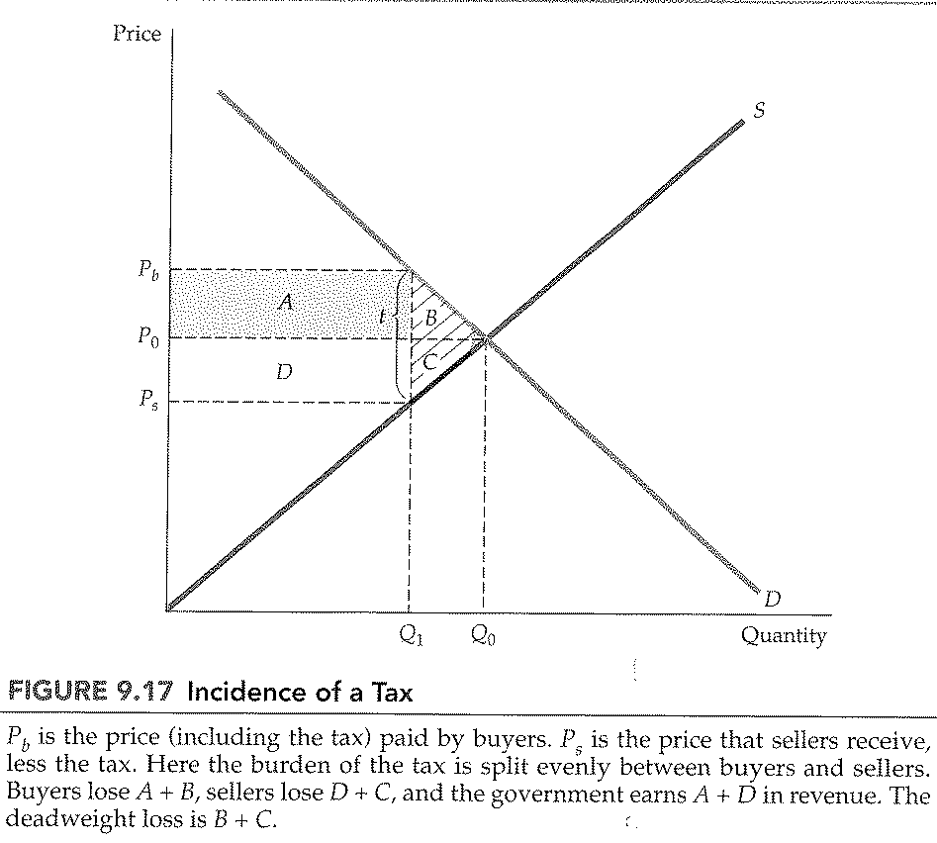

CHAPTER 9: The analysis of competitive markets
Impact of a tax depends on elasticities of supply and demand
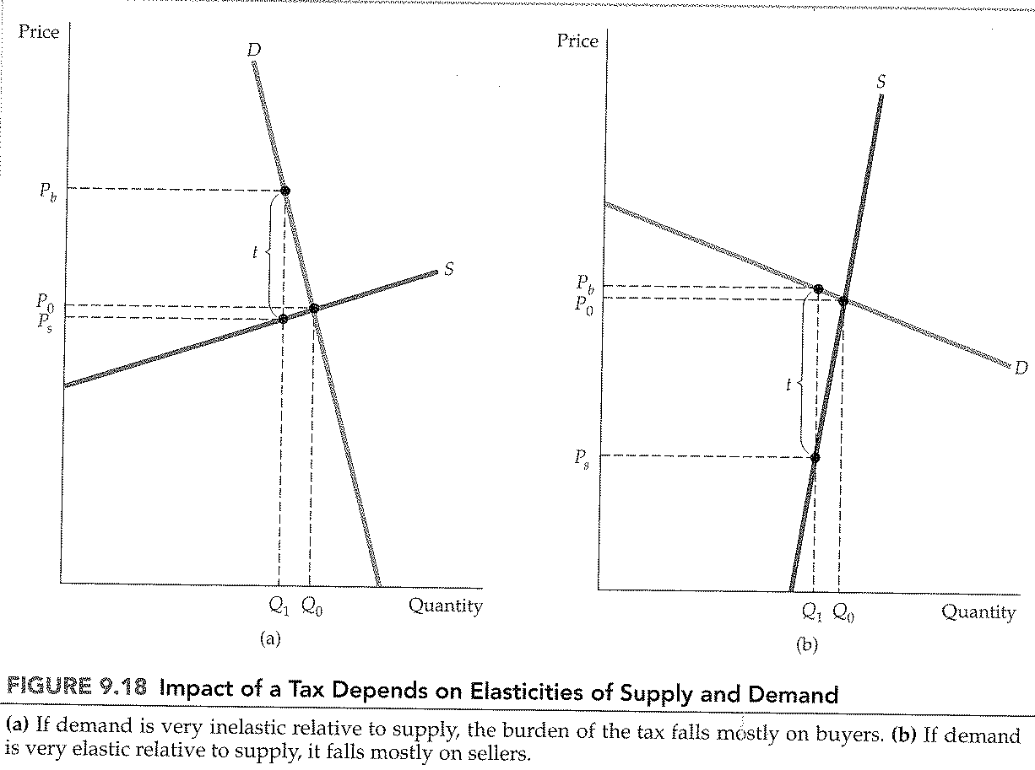
CHAPTER 9: The analysis of competitive markets
Subsidy
